**Chapter 1**

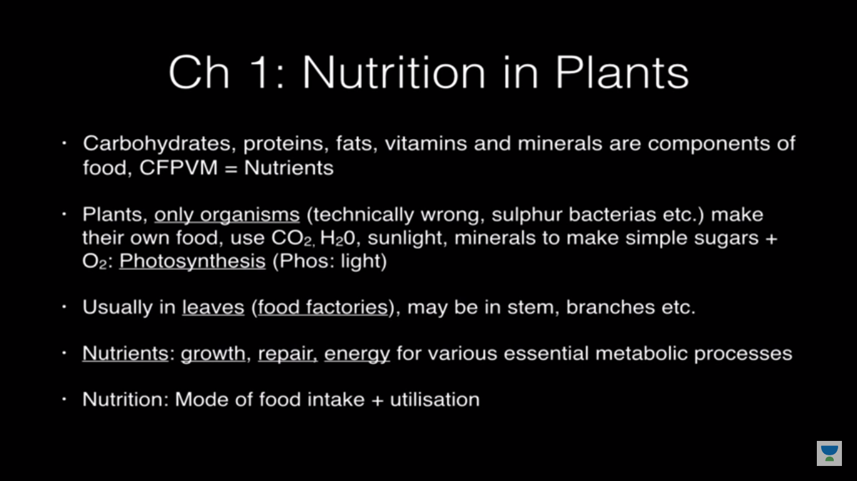

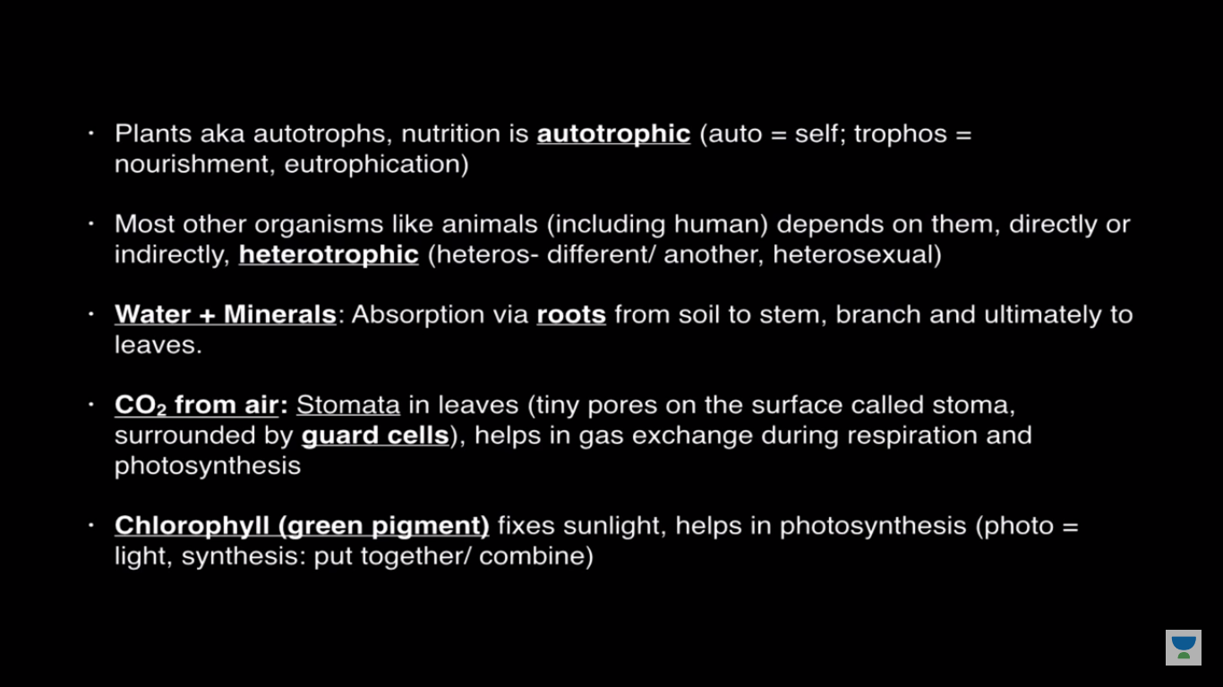

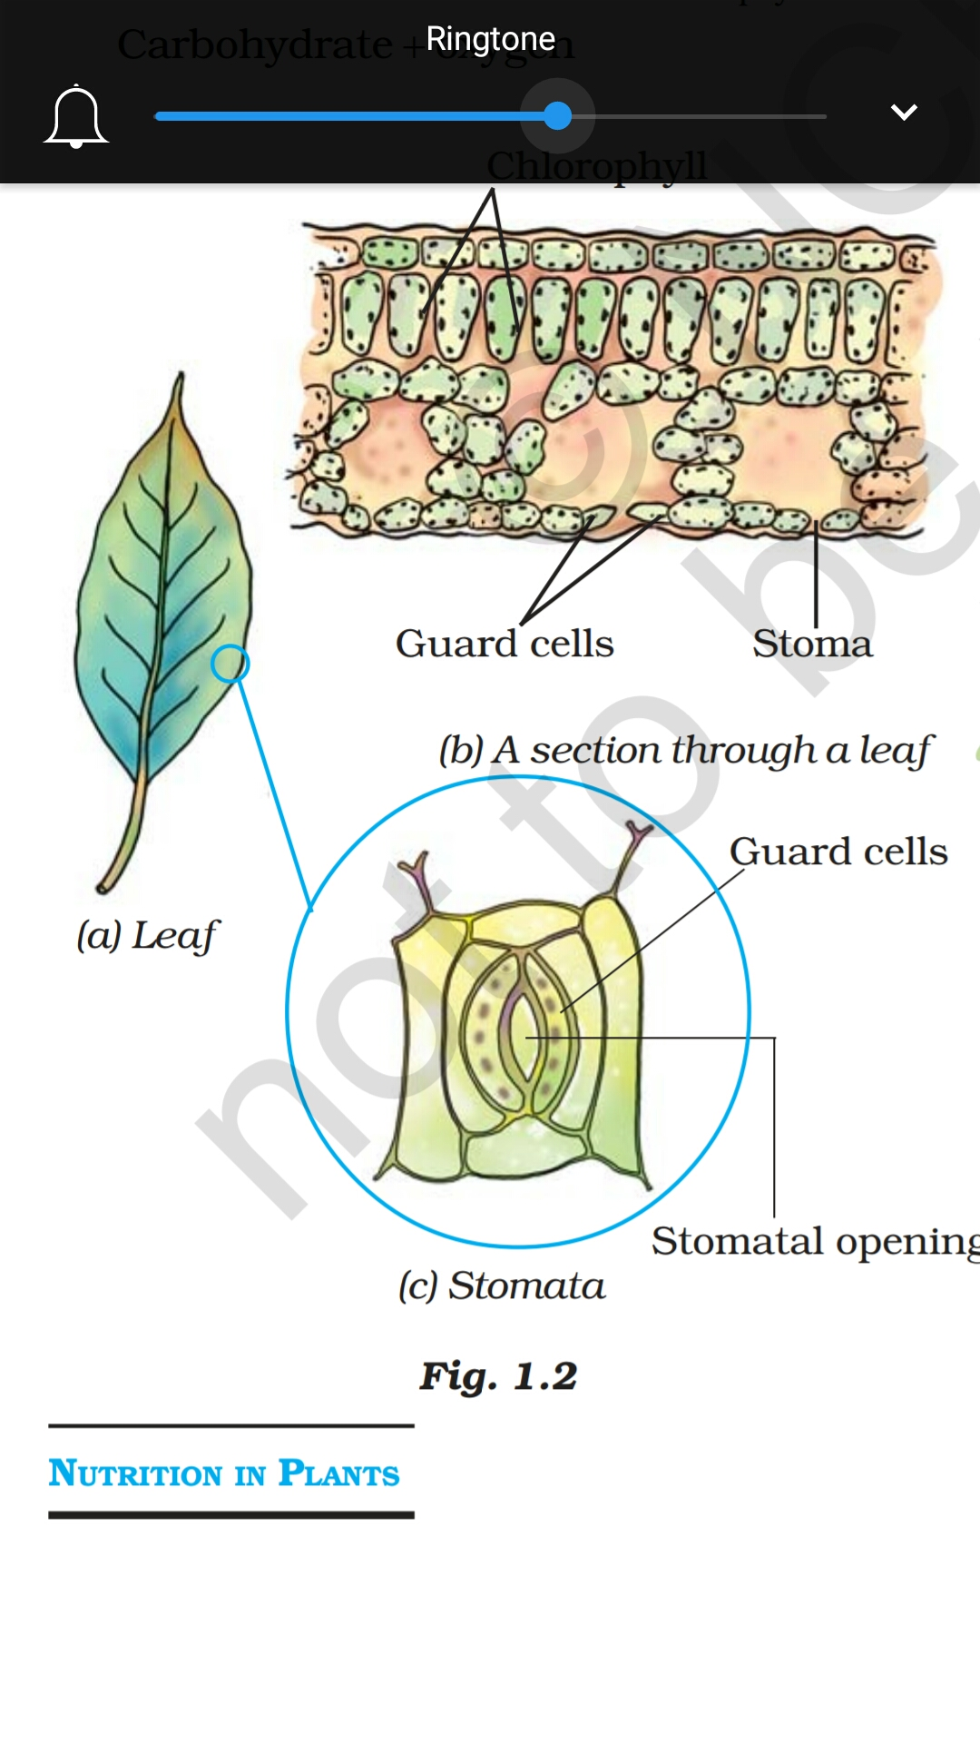

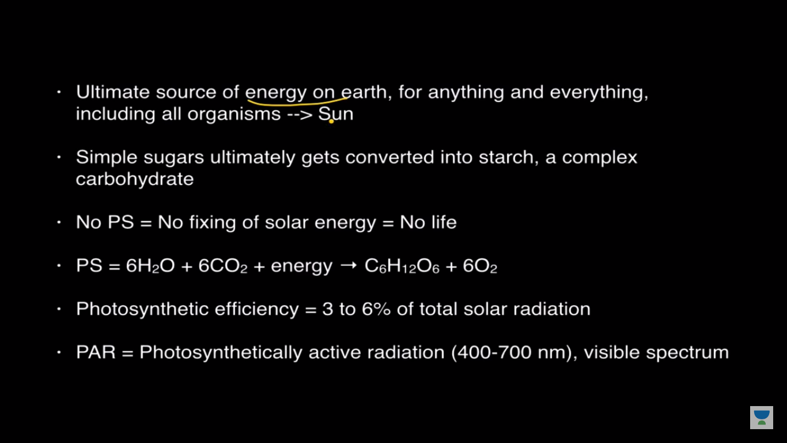

mono sacrite- Glucose,galactose,fructose

dia scarite-maltose

table sugar->sucrose==glucose+fructose

Lctose=glocose+galactose

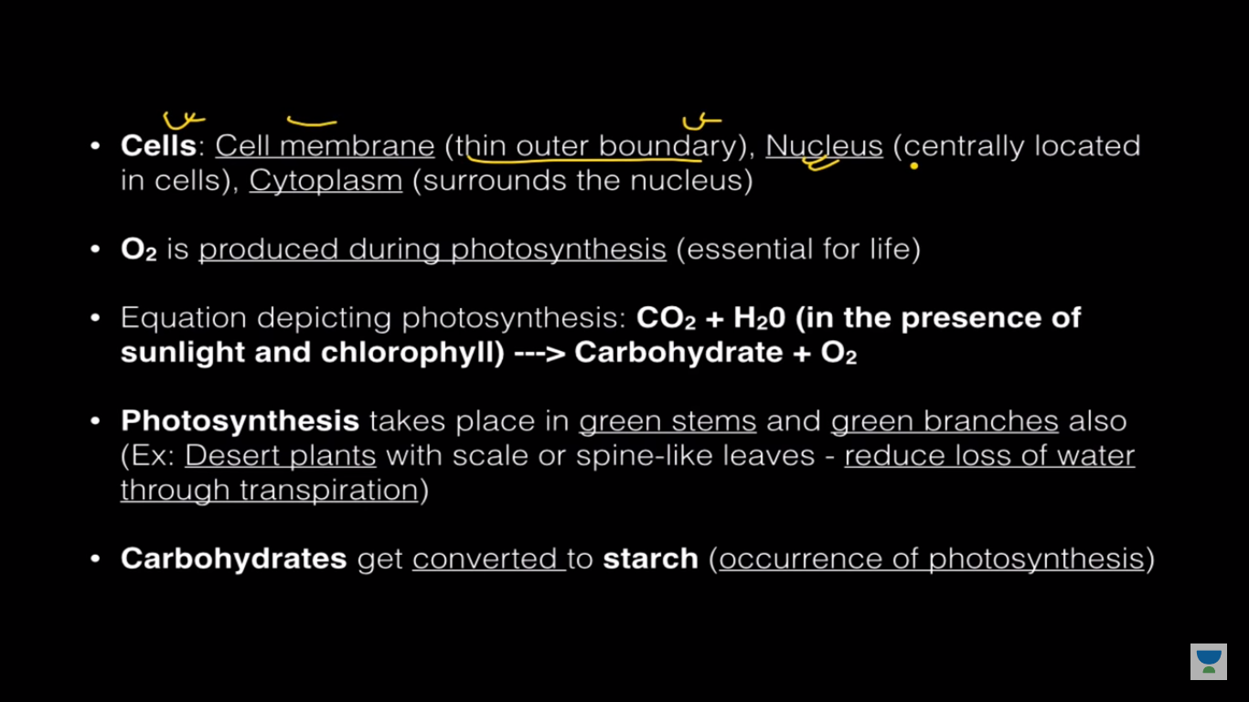

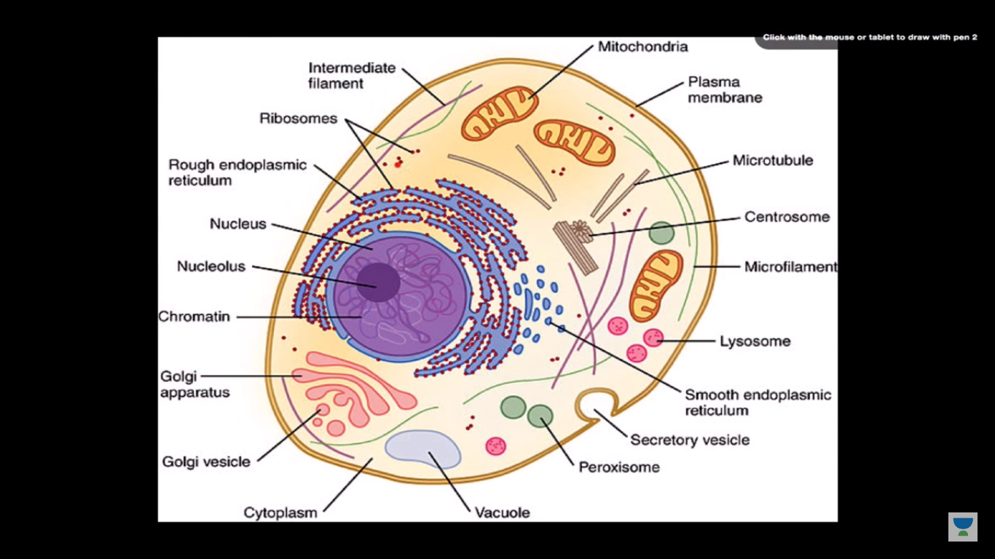

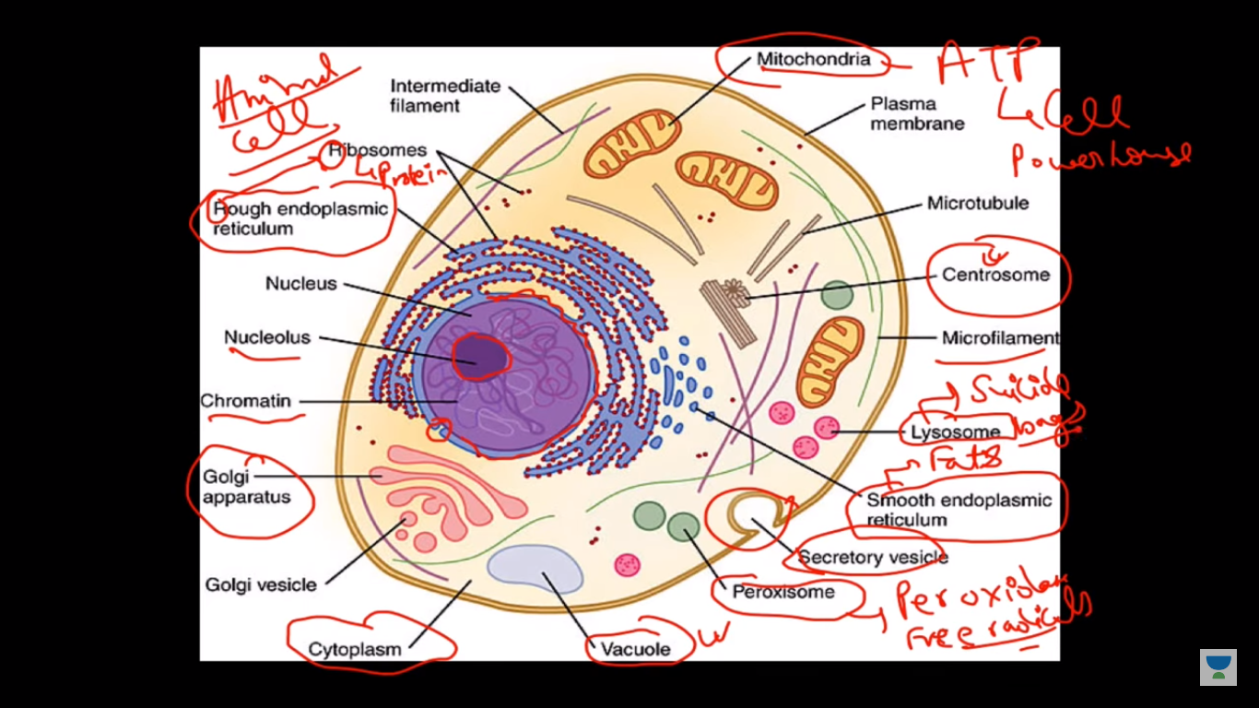

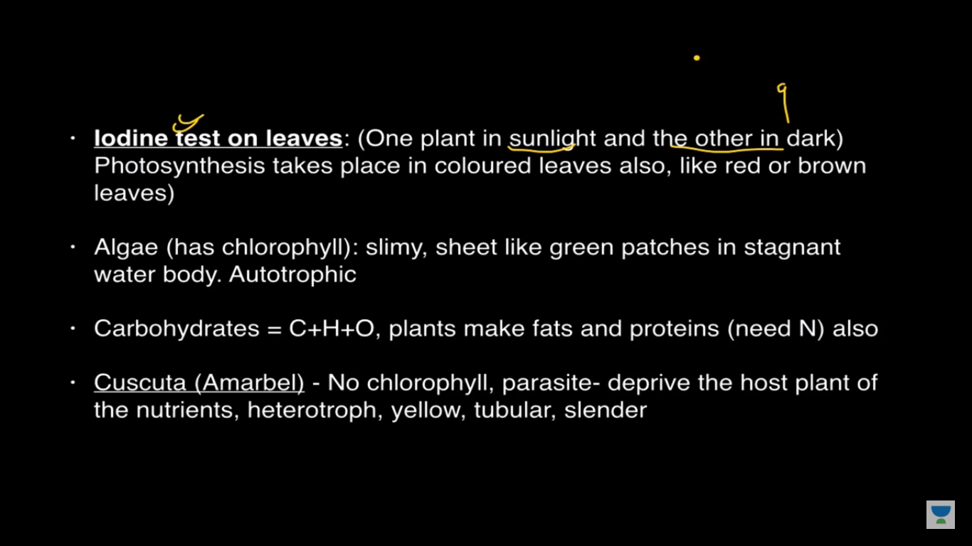

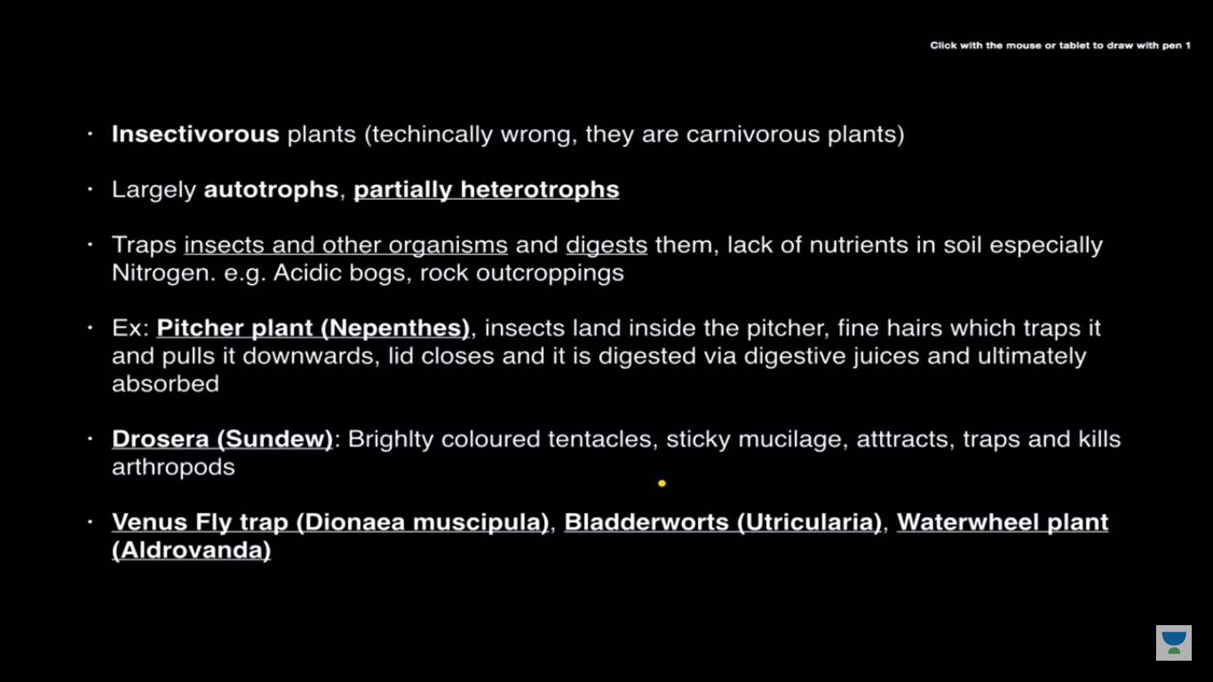

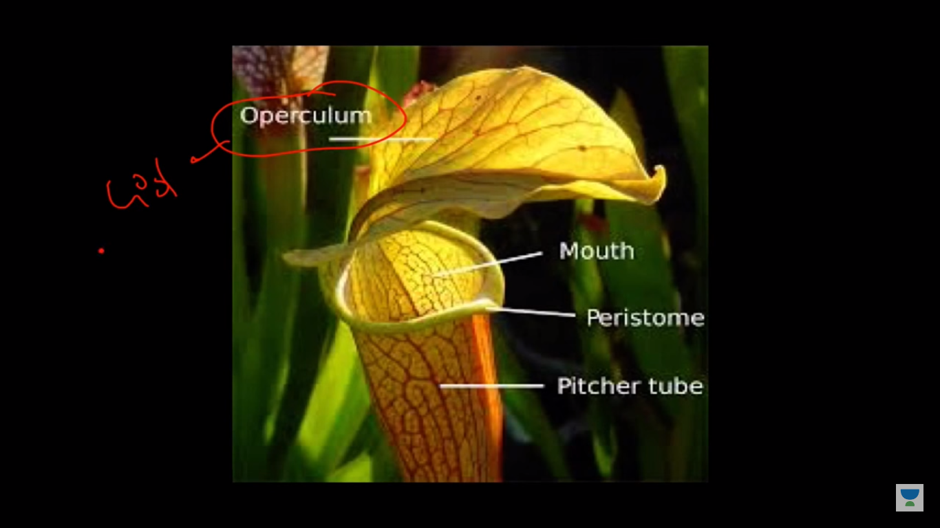

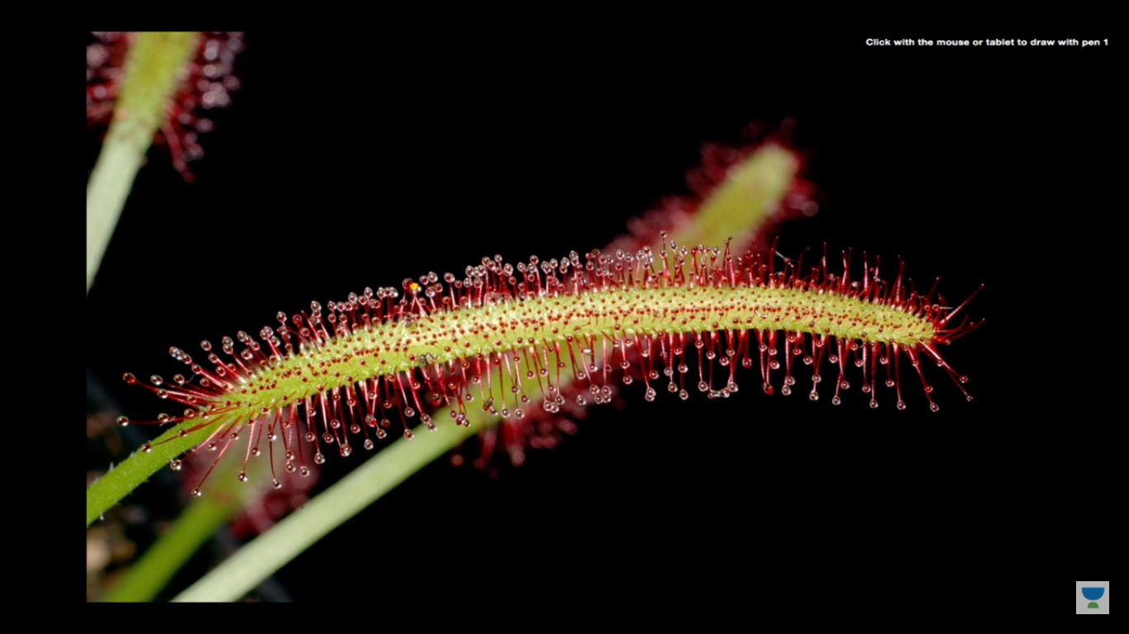

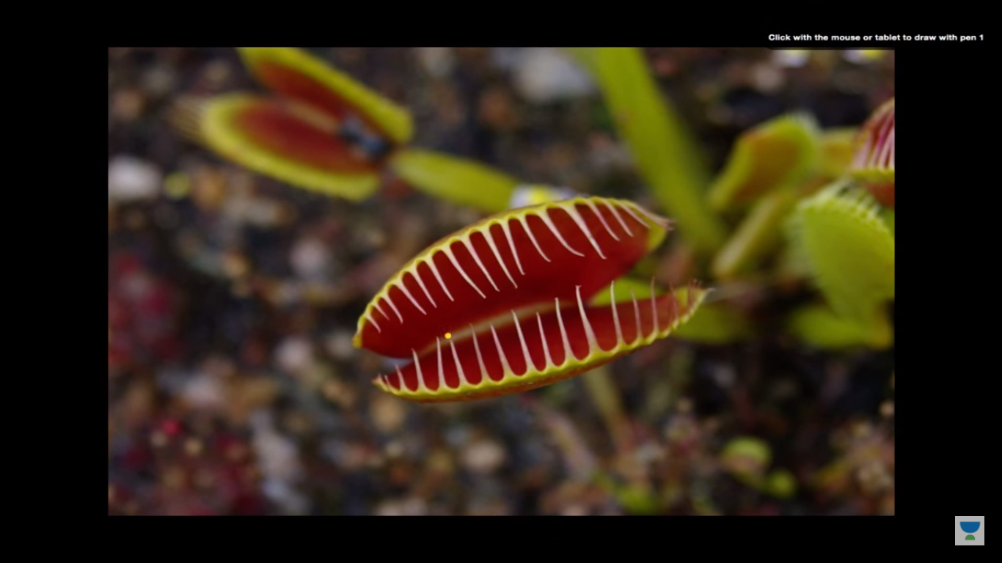

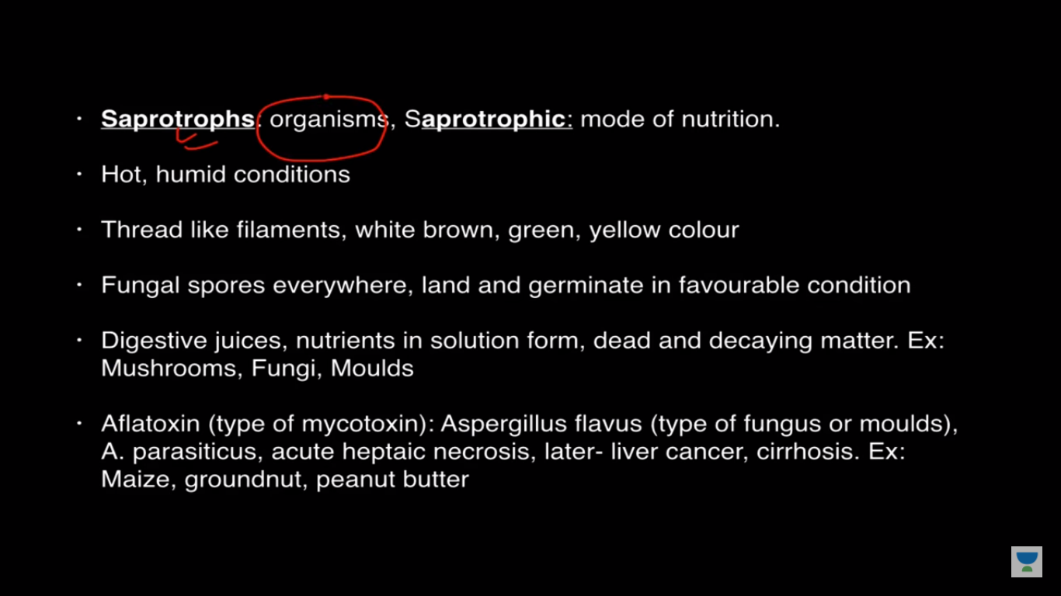

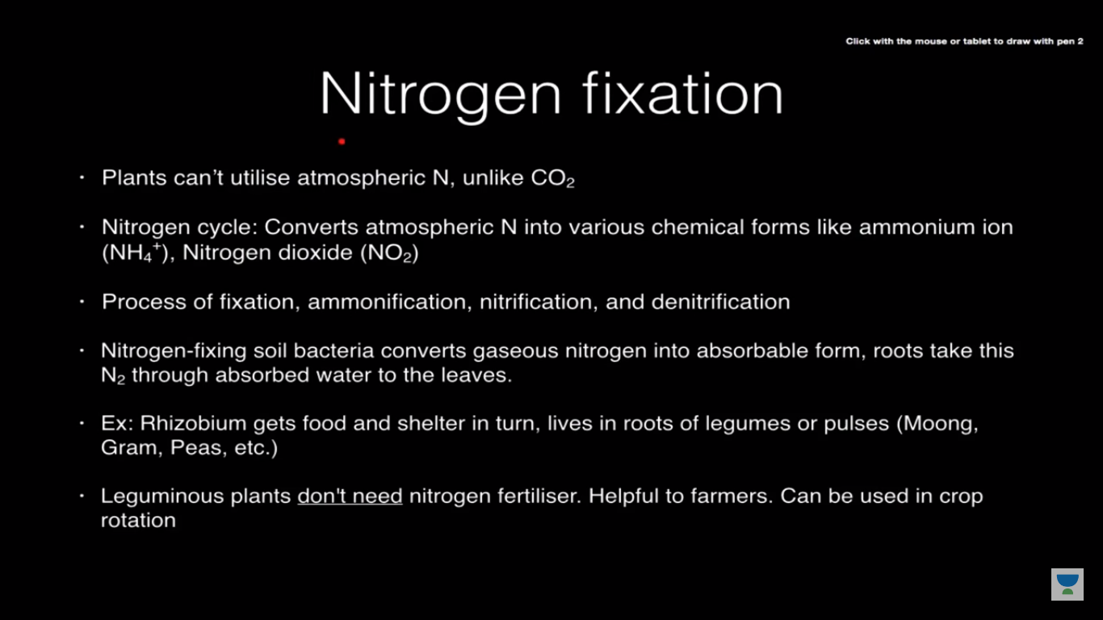

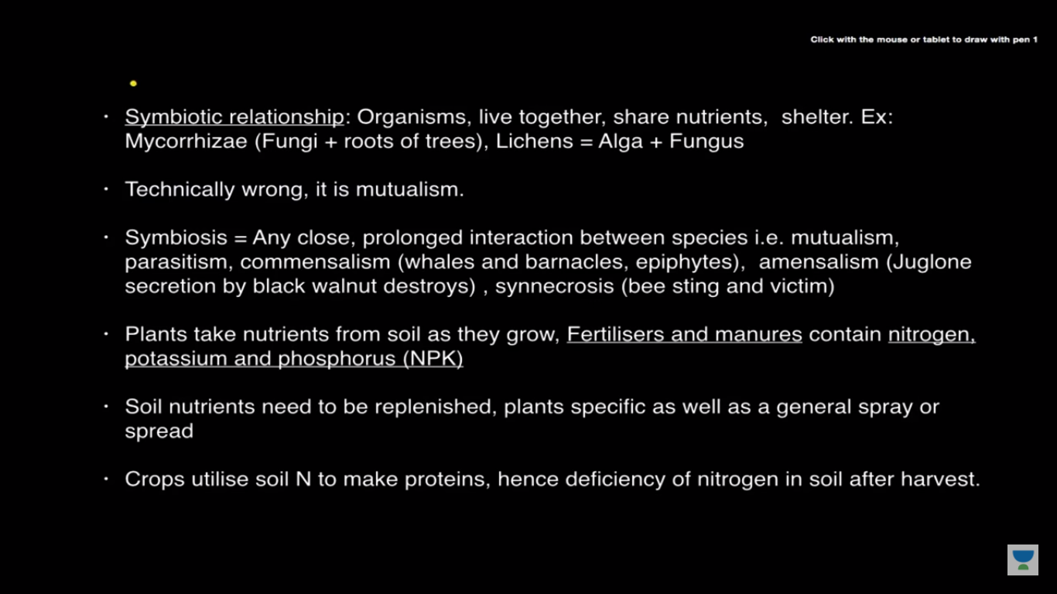

**Chapter 2**

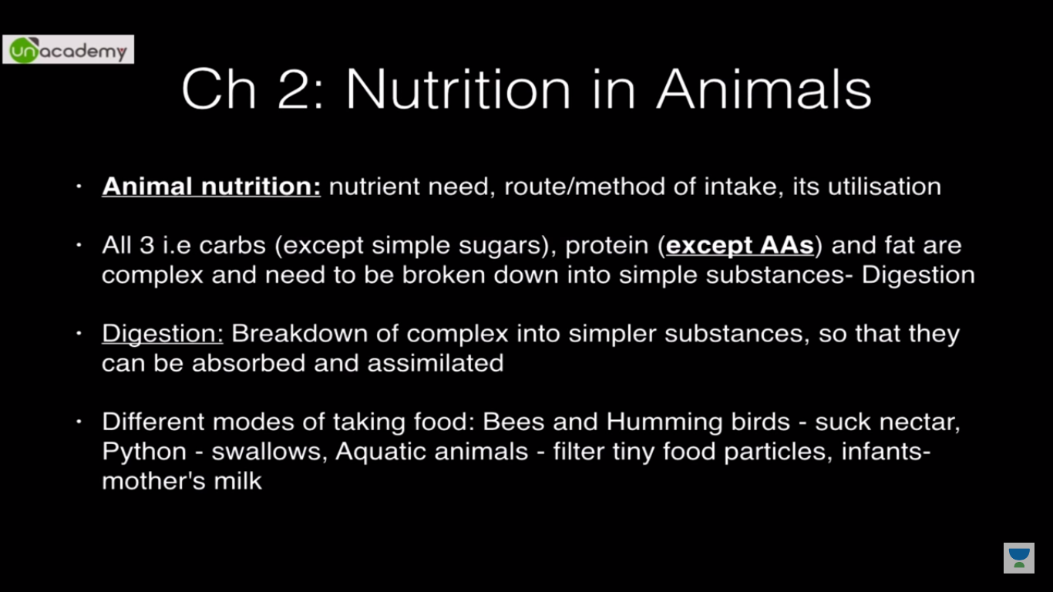

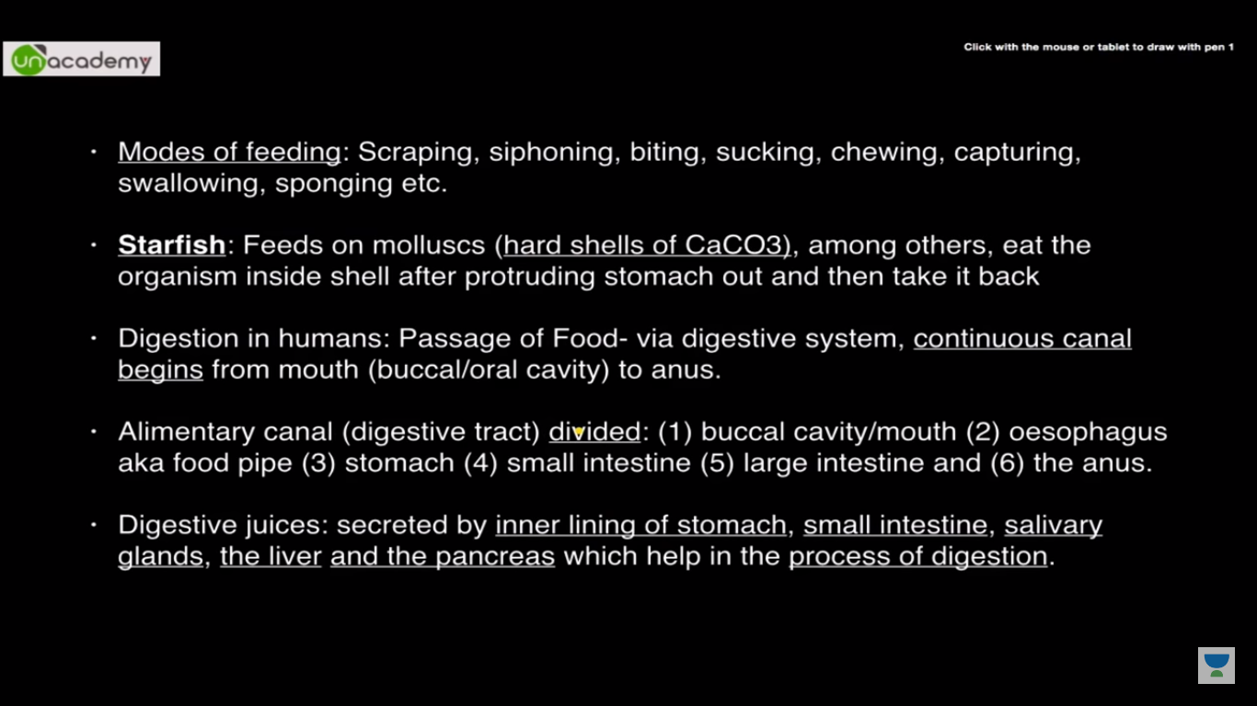

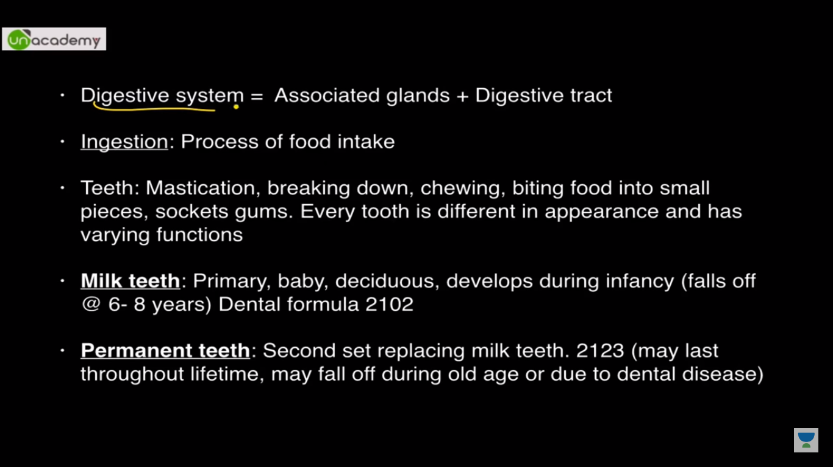

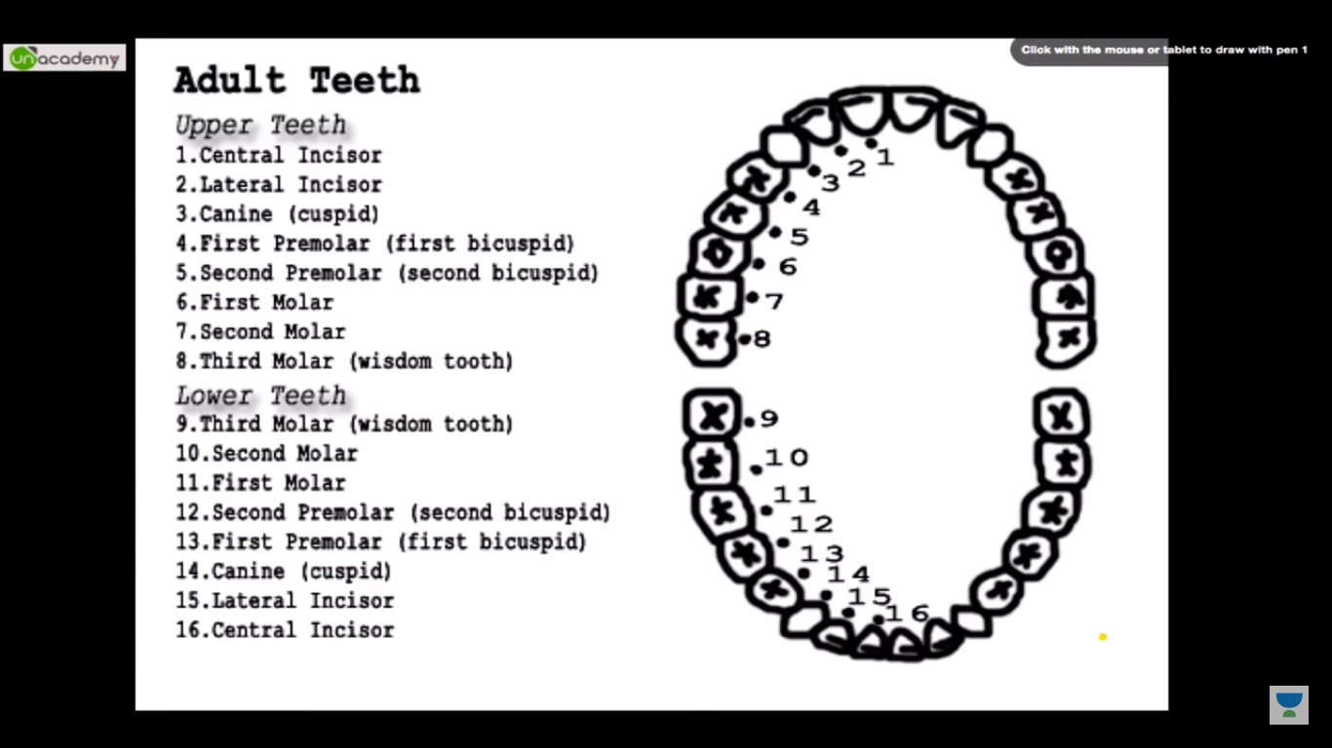

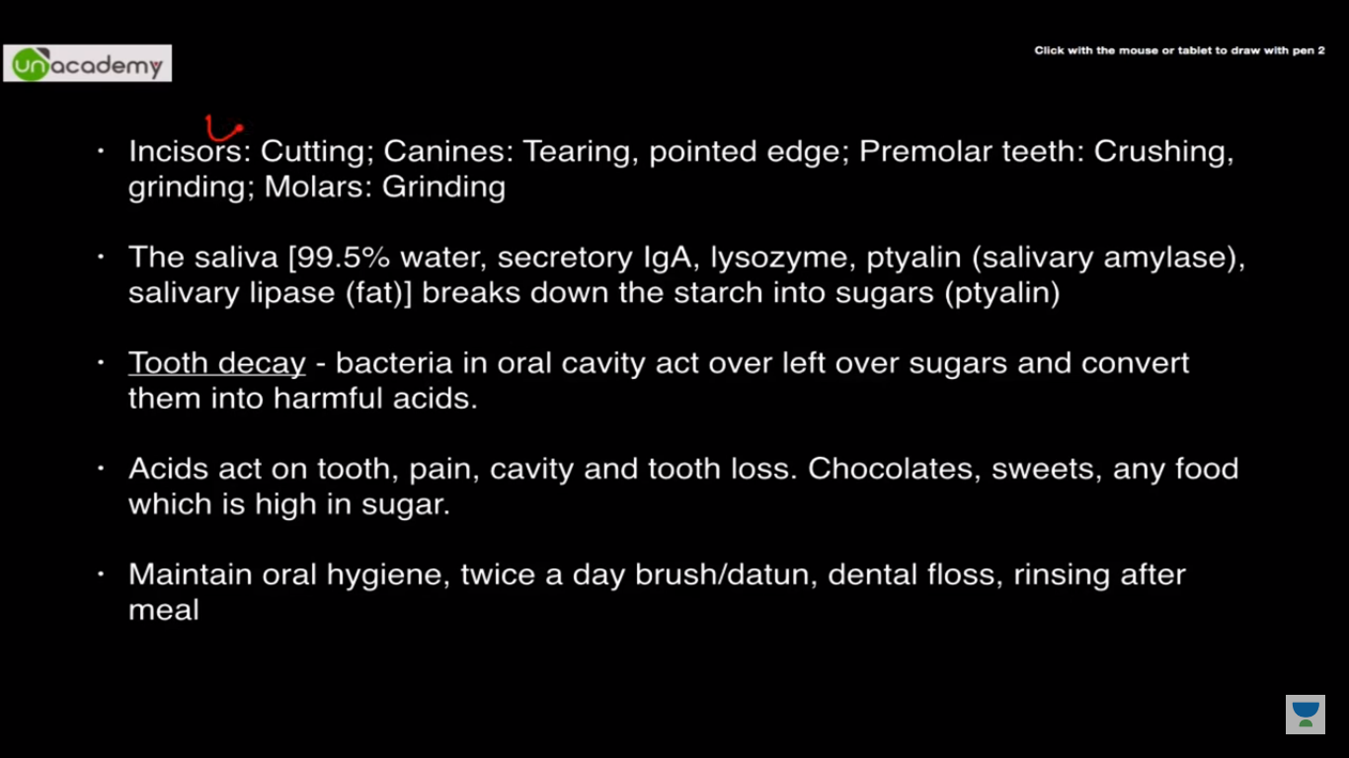

Secretory IgA-->GAMDE--Prevention of infection

Enamel is the hardest substance in animal kingdom

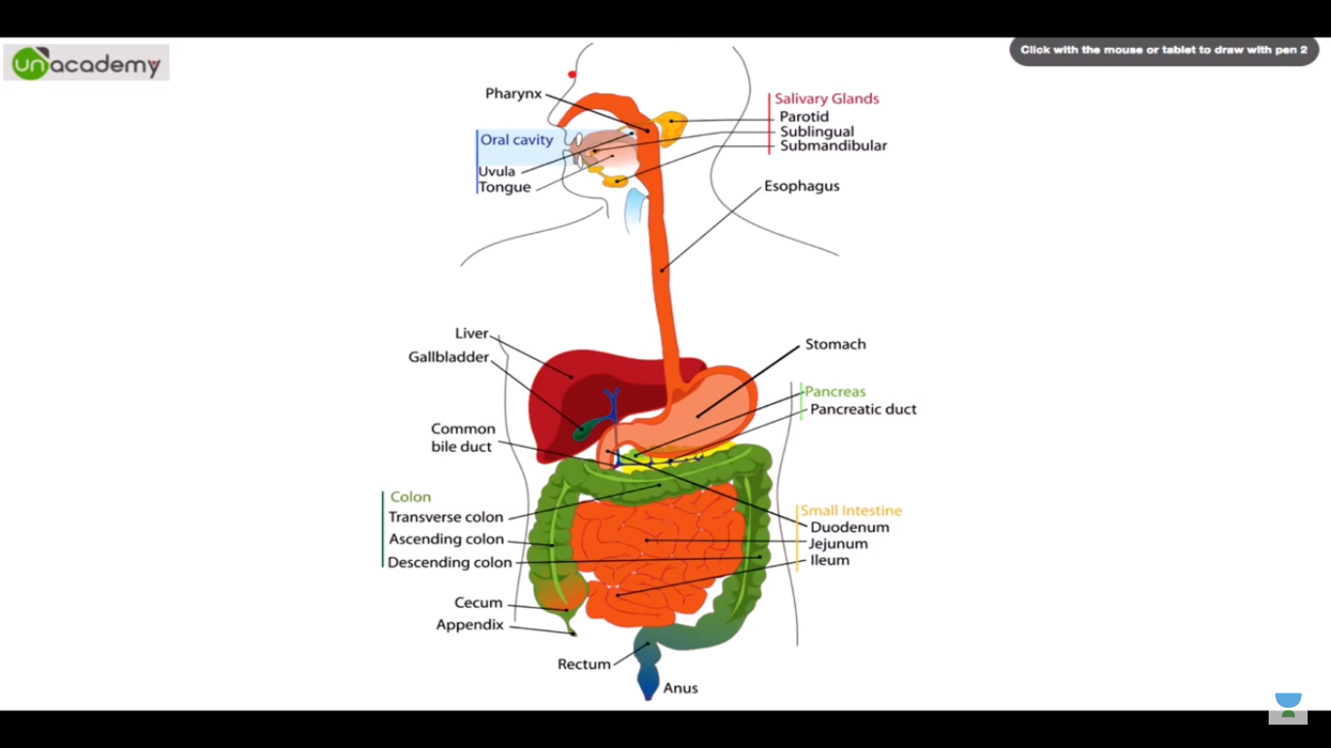

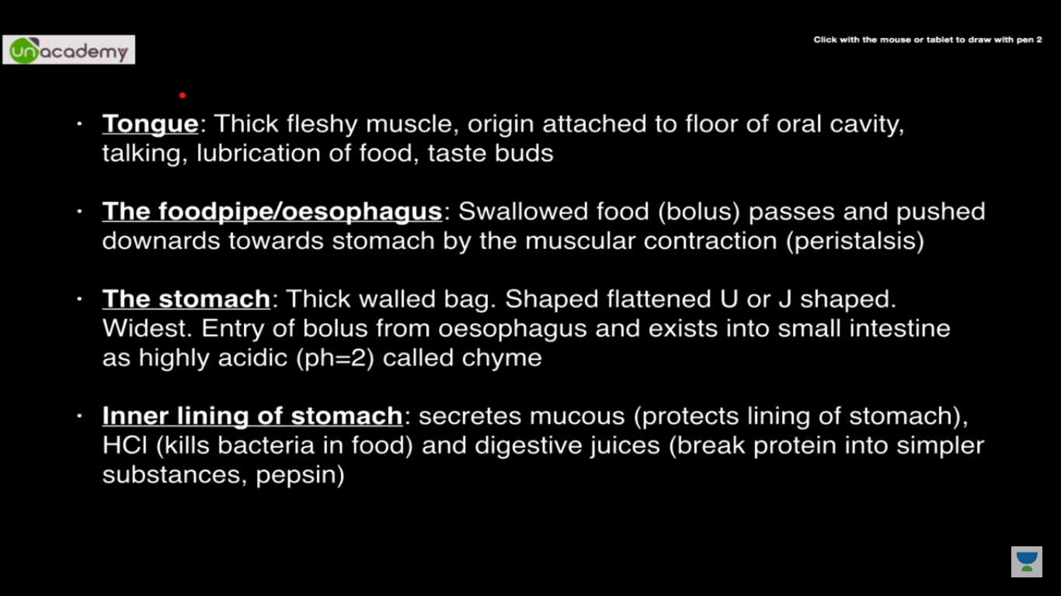

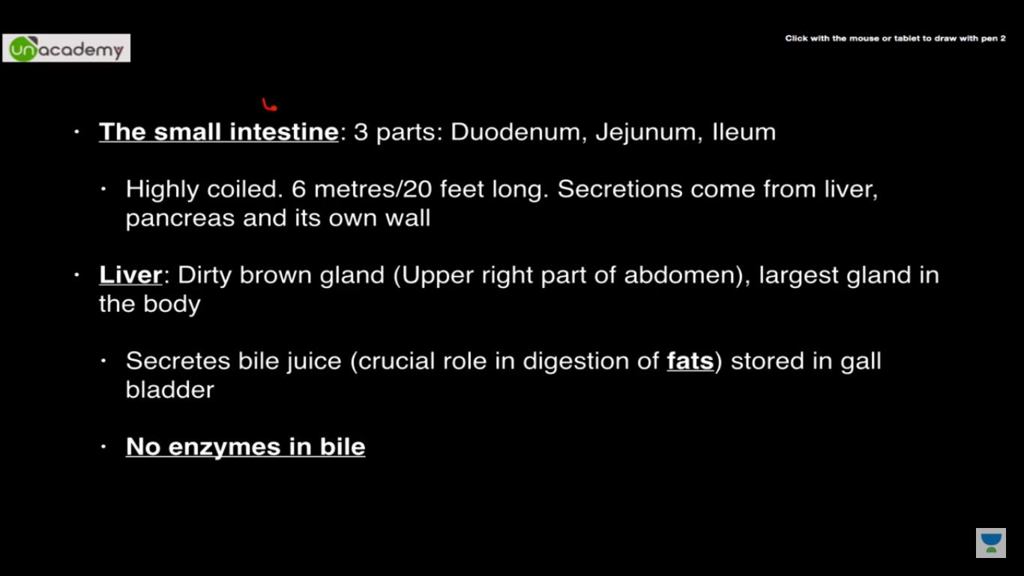

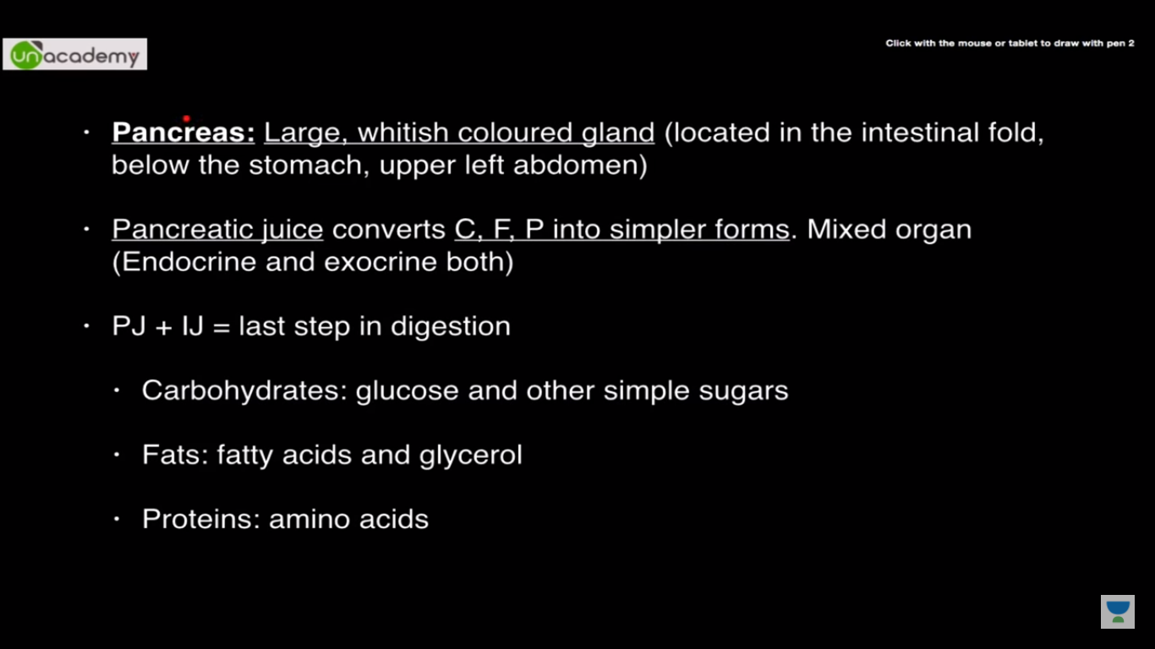

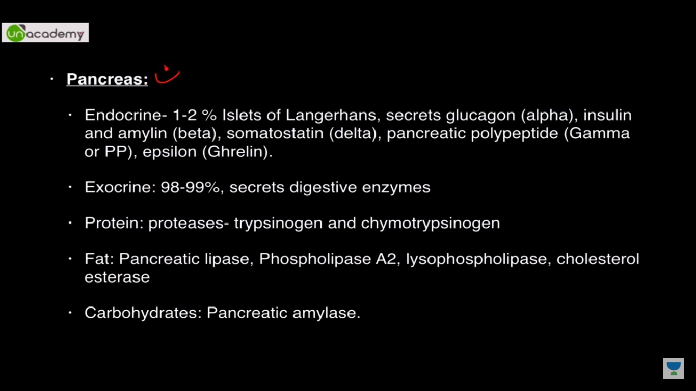

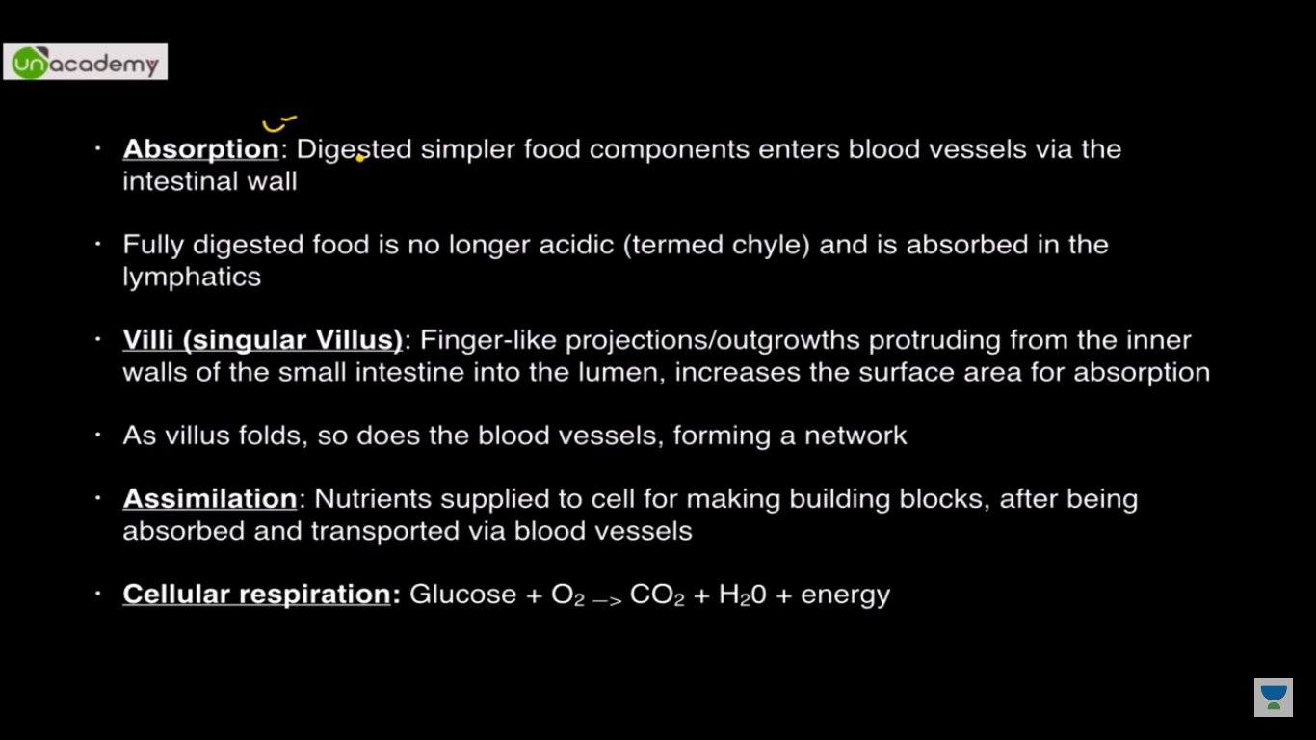

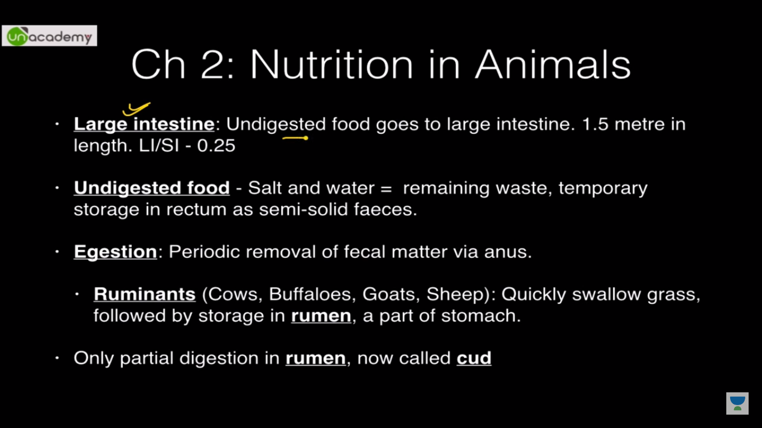

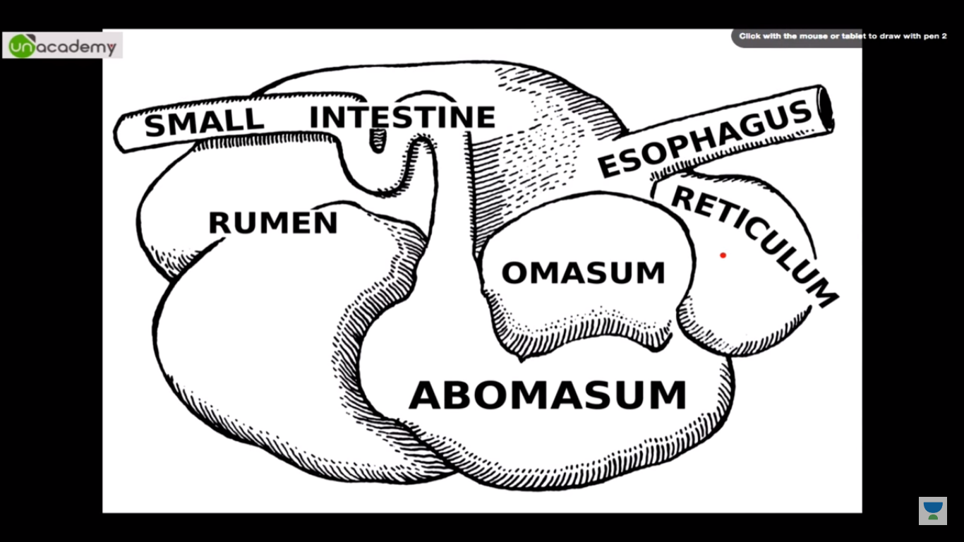

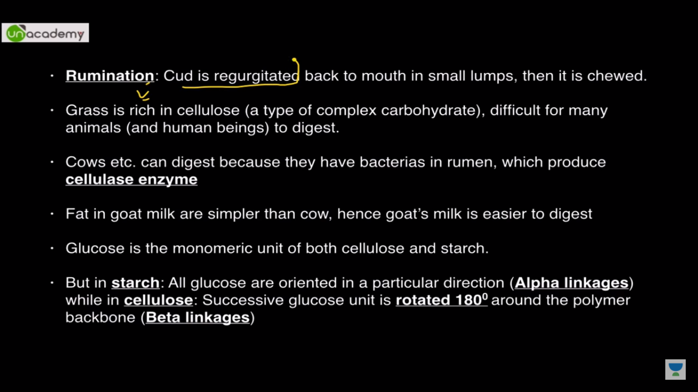

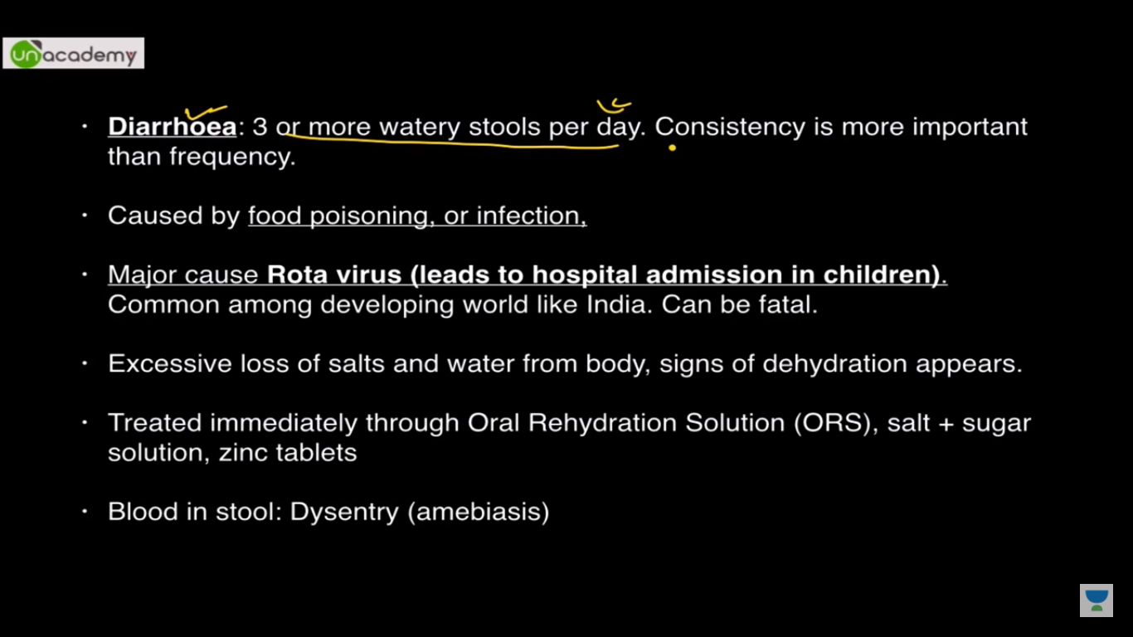

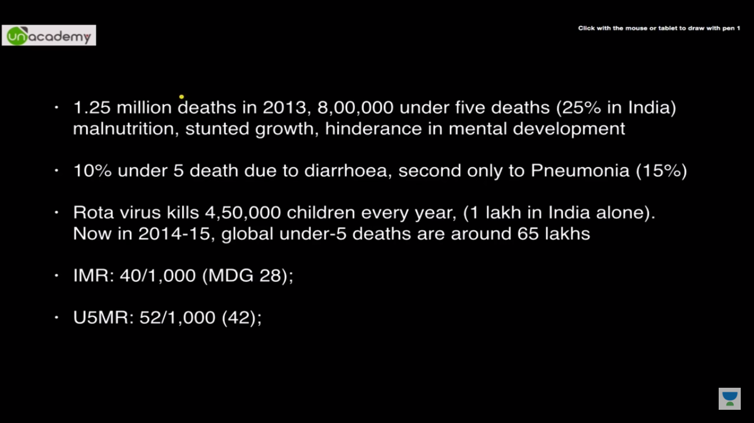

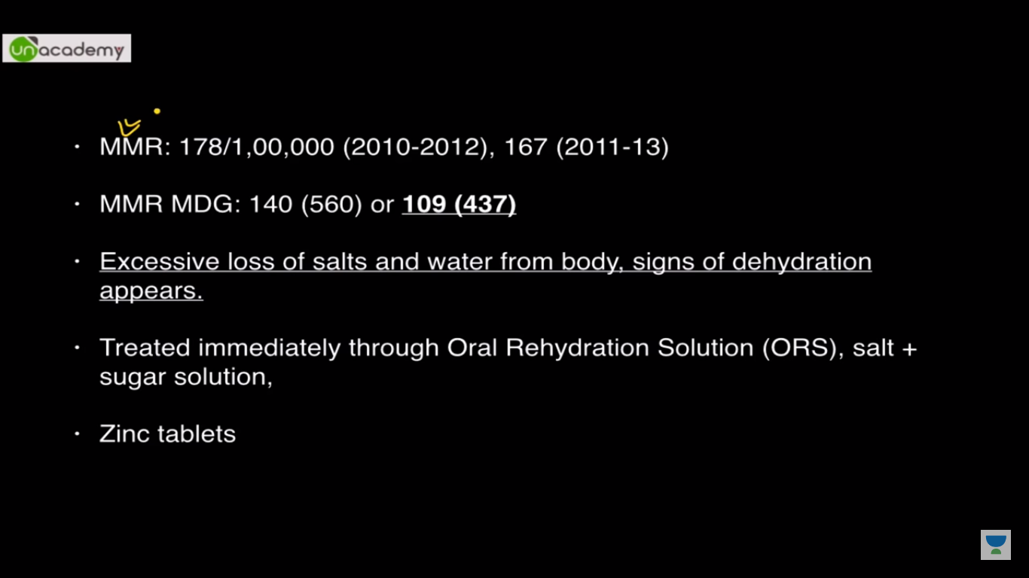

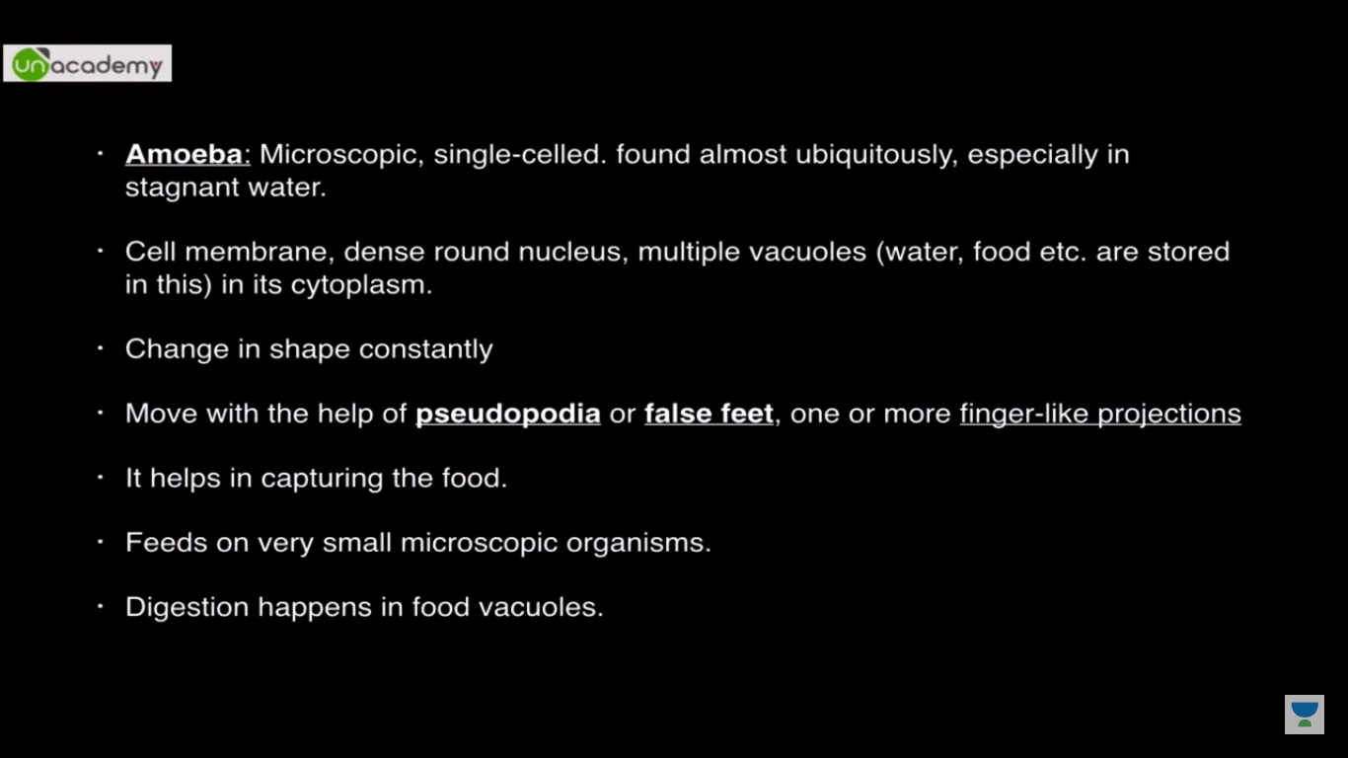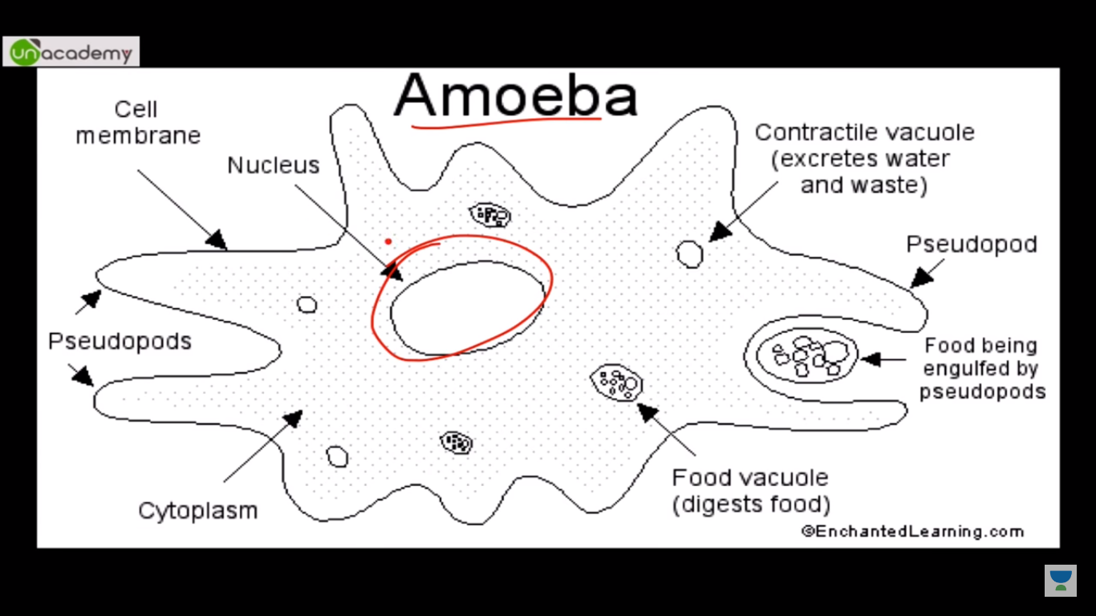

**Chapter3:**

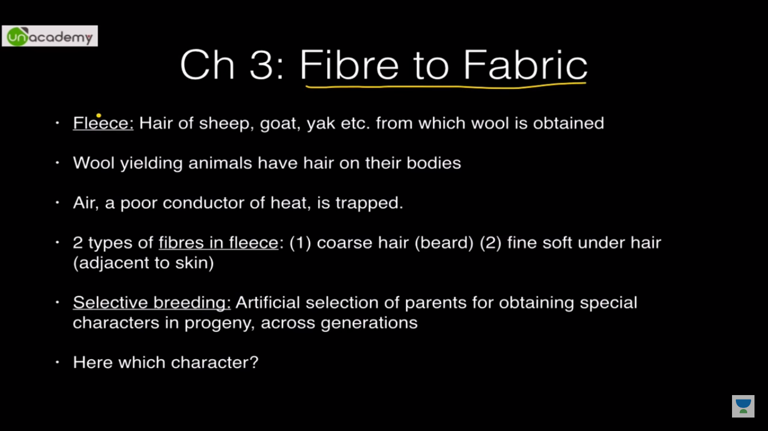

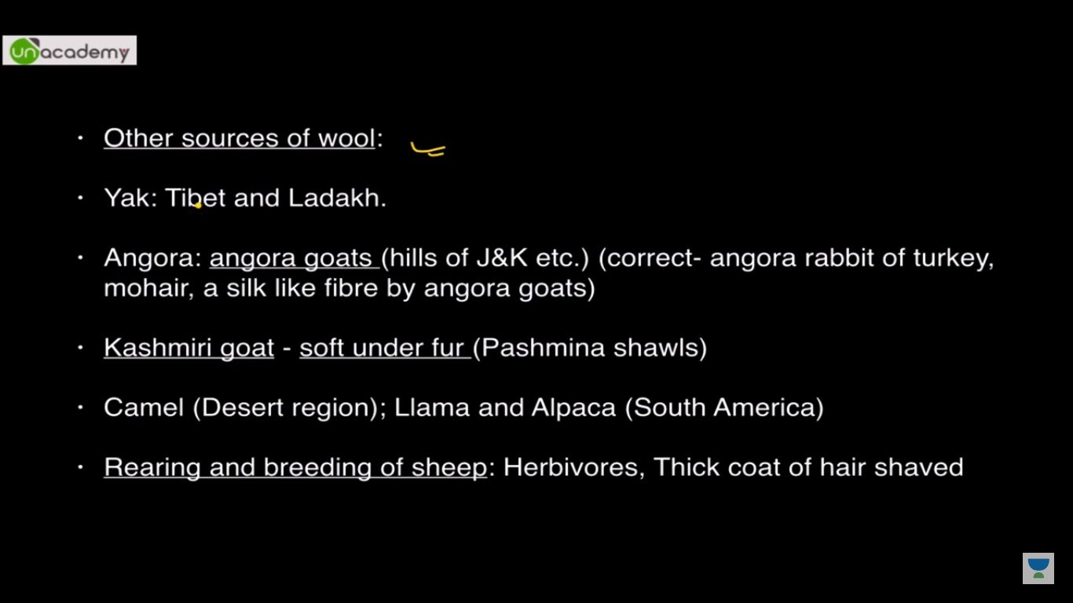

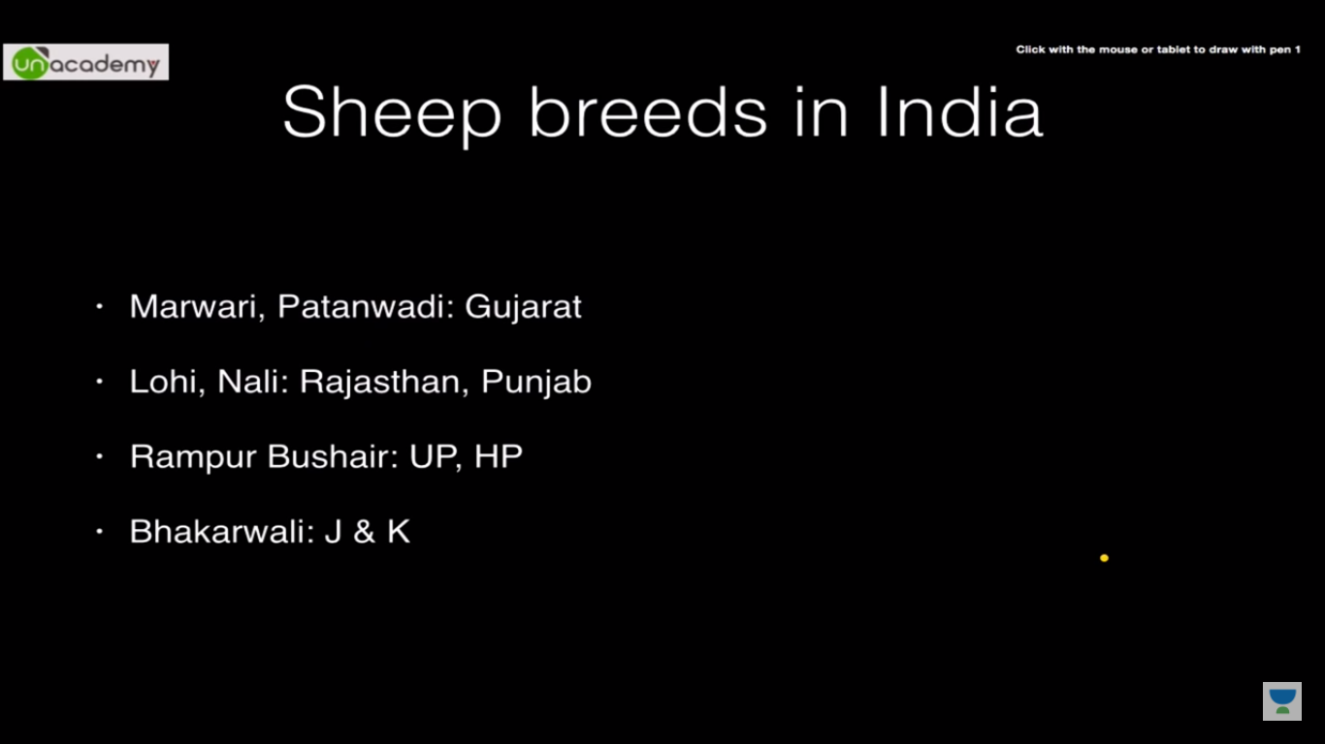

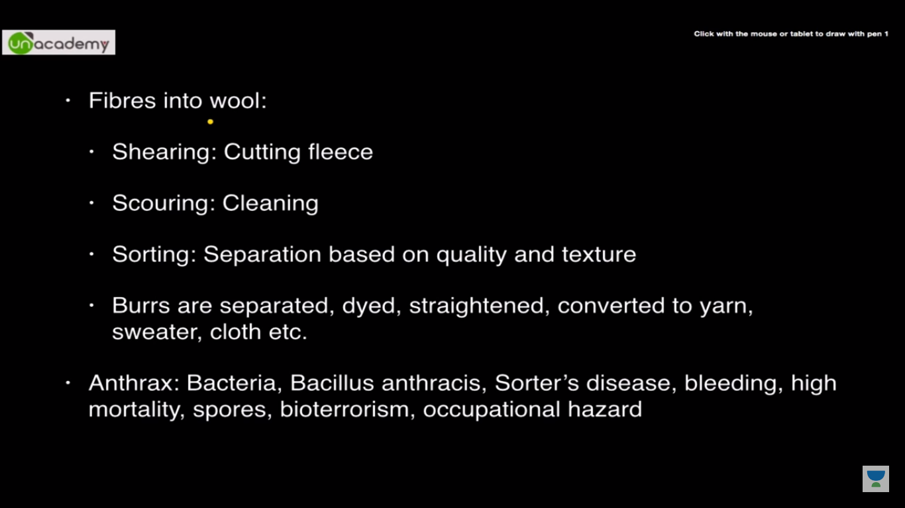

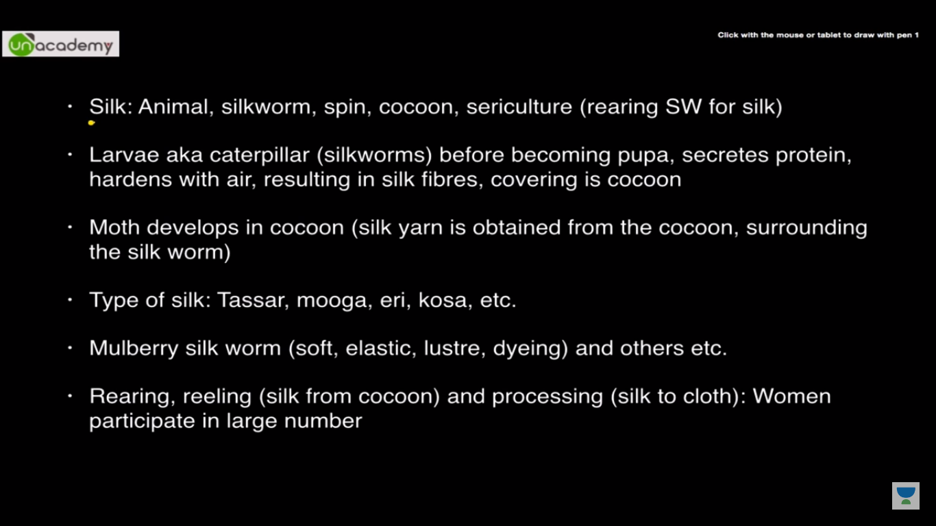

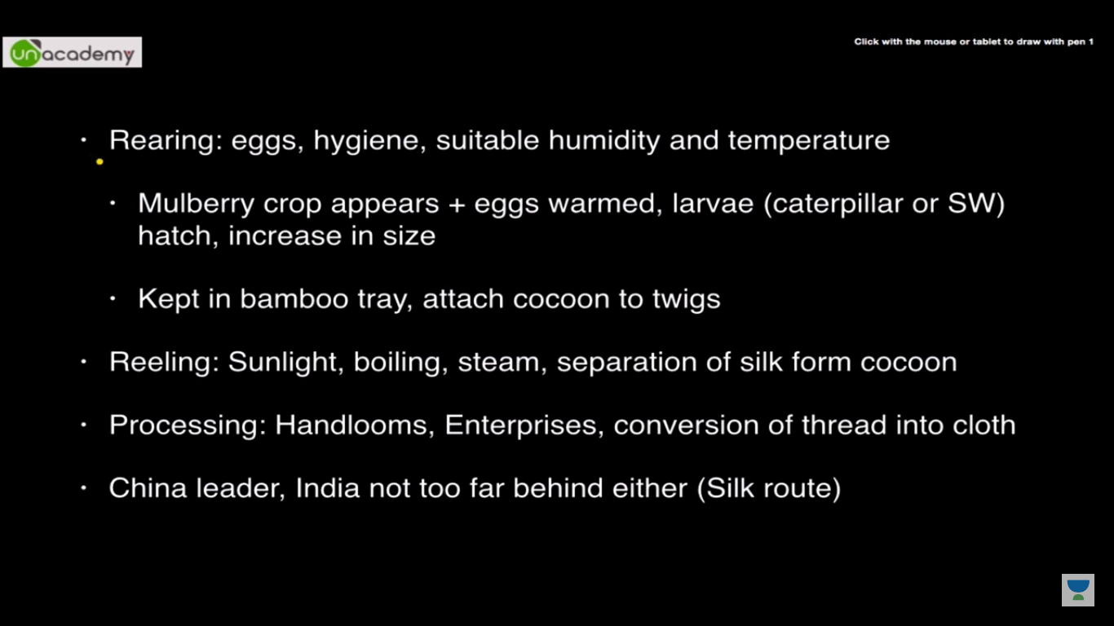

**Chapter 4**

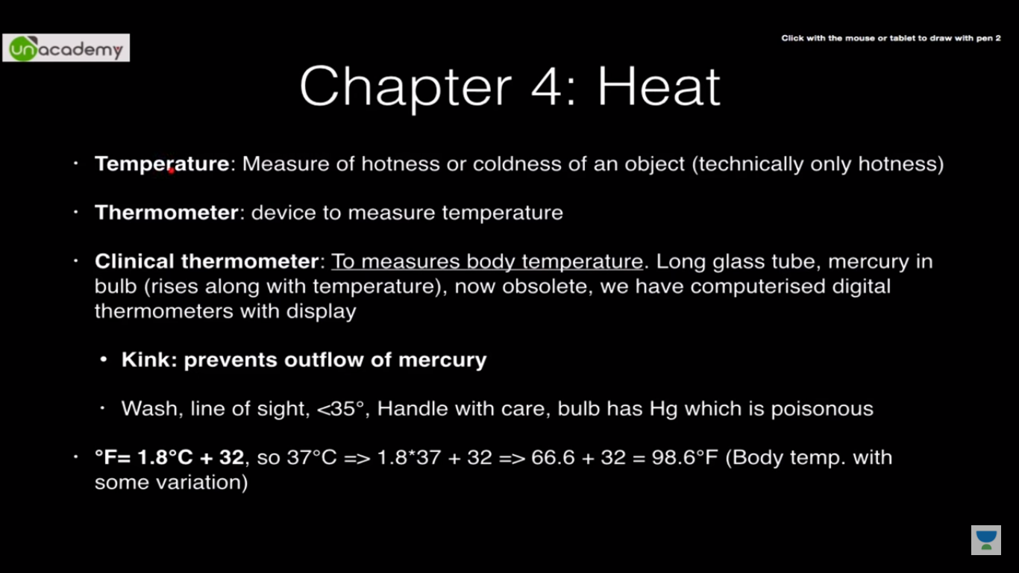

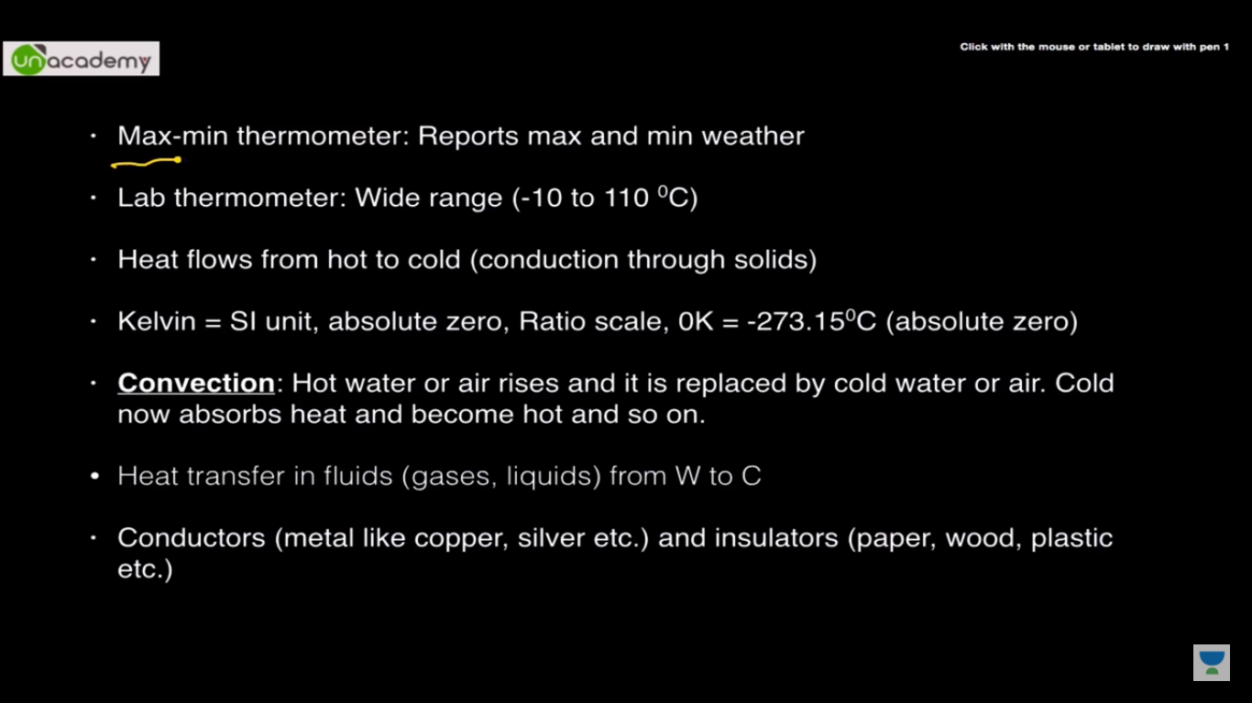

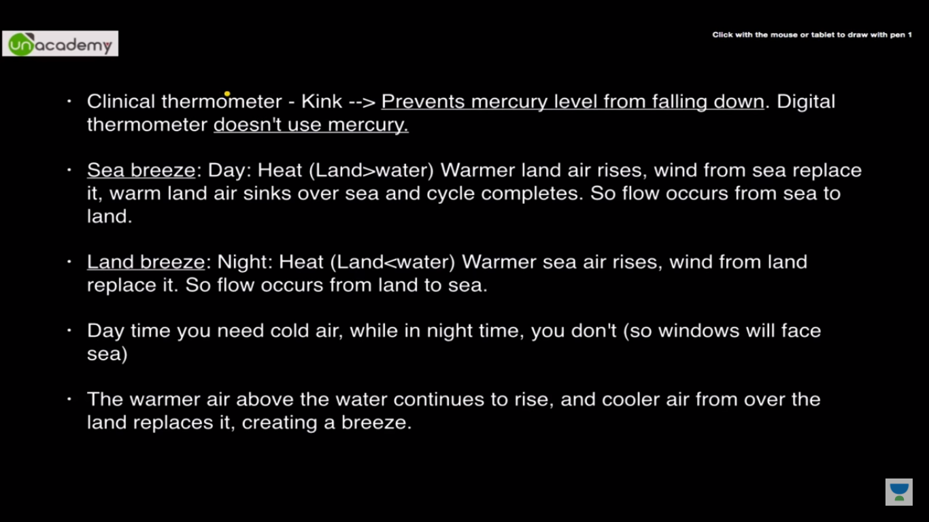

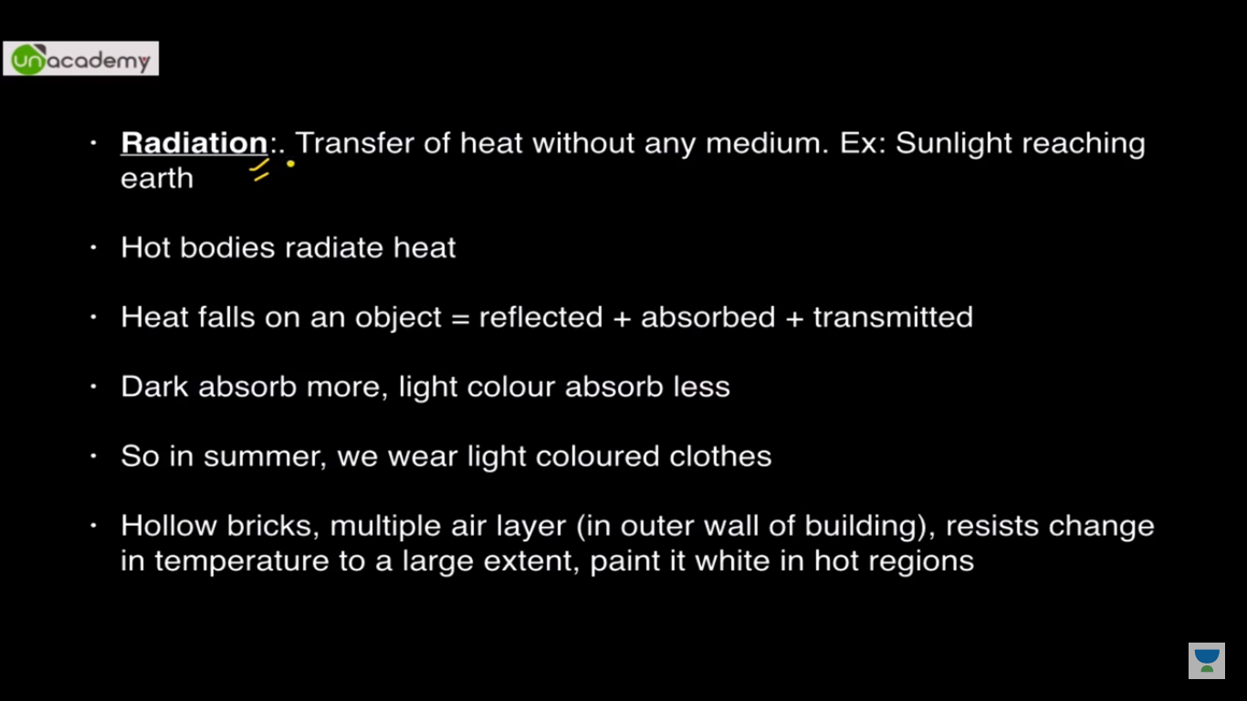

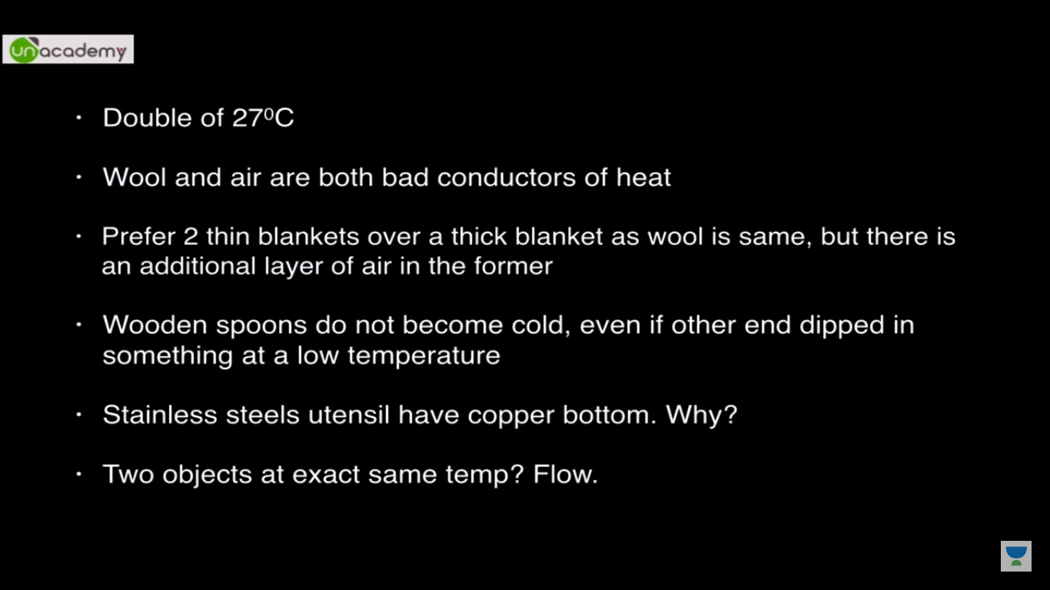

Dynamic equilibrium: Change of heat in same temp

**Chapter 5**

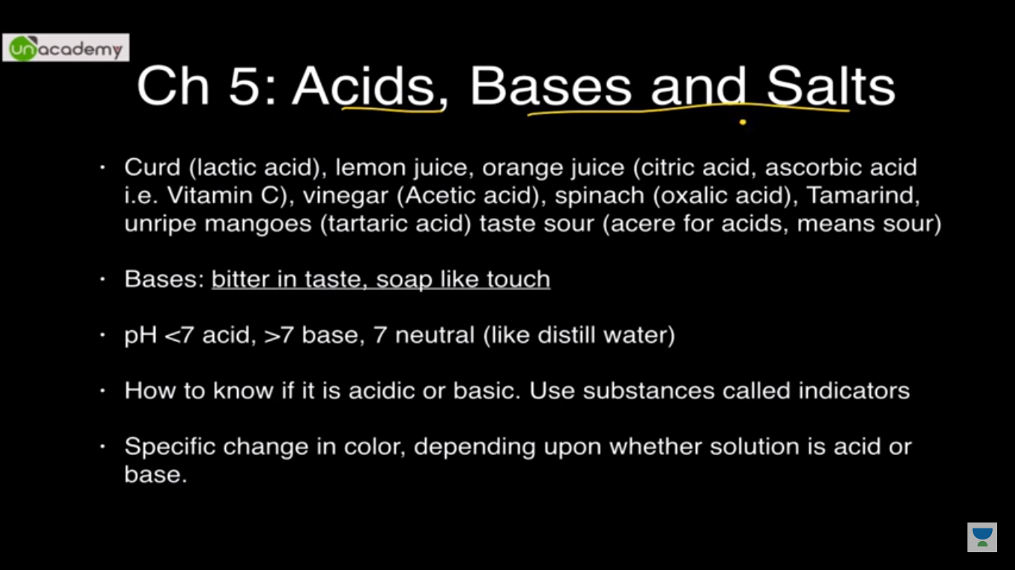

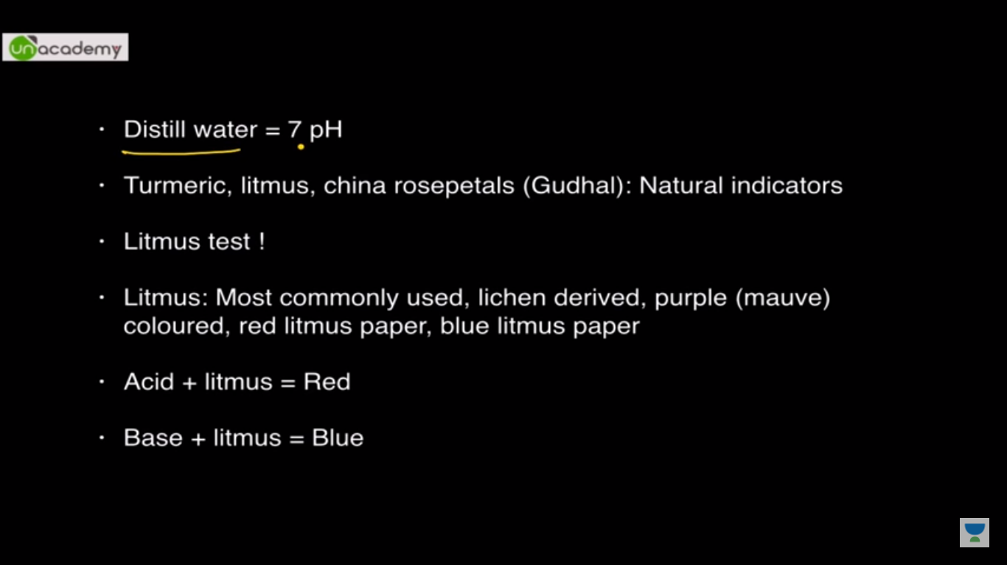

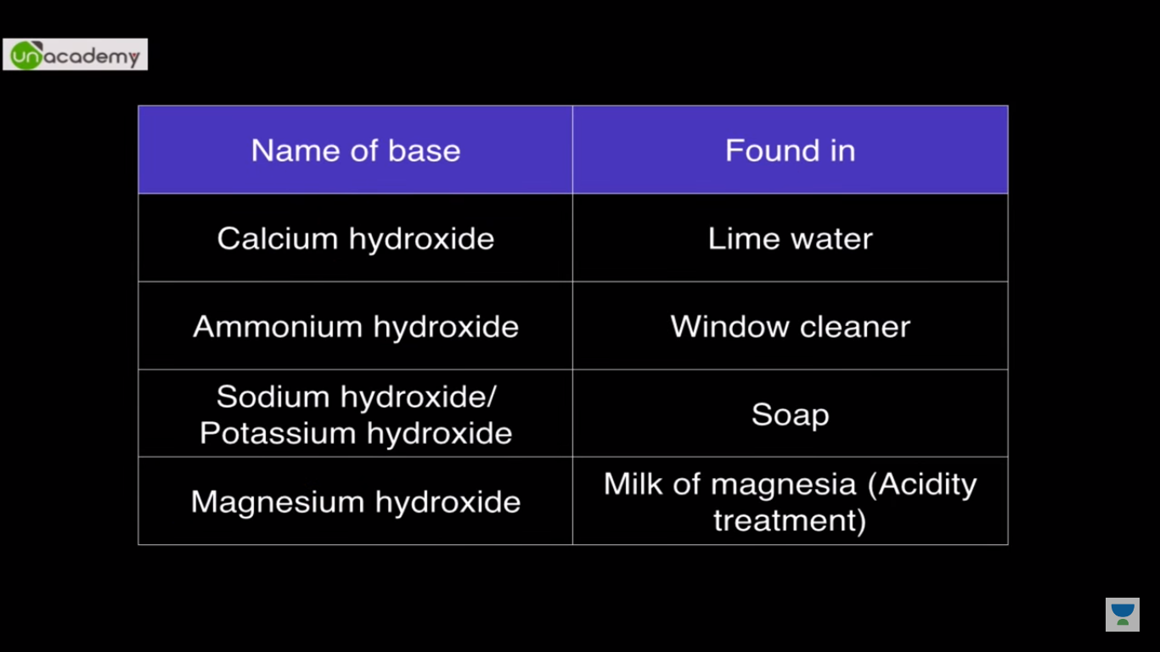

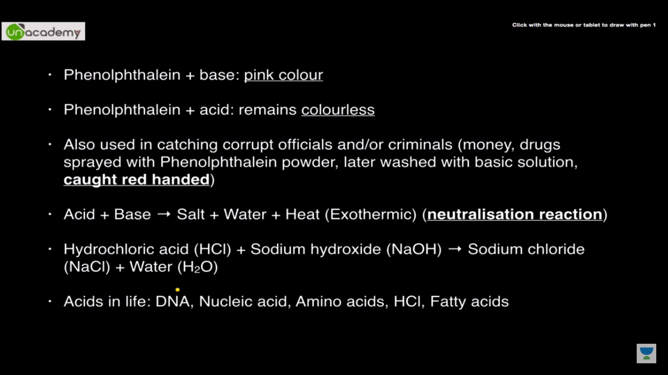

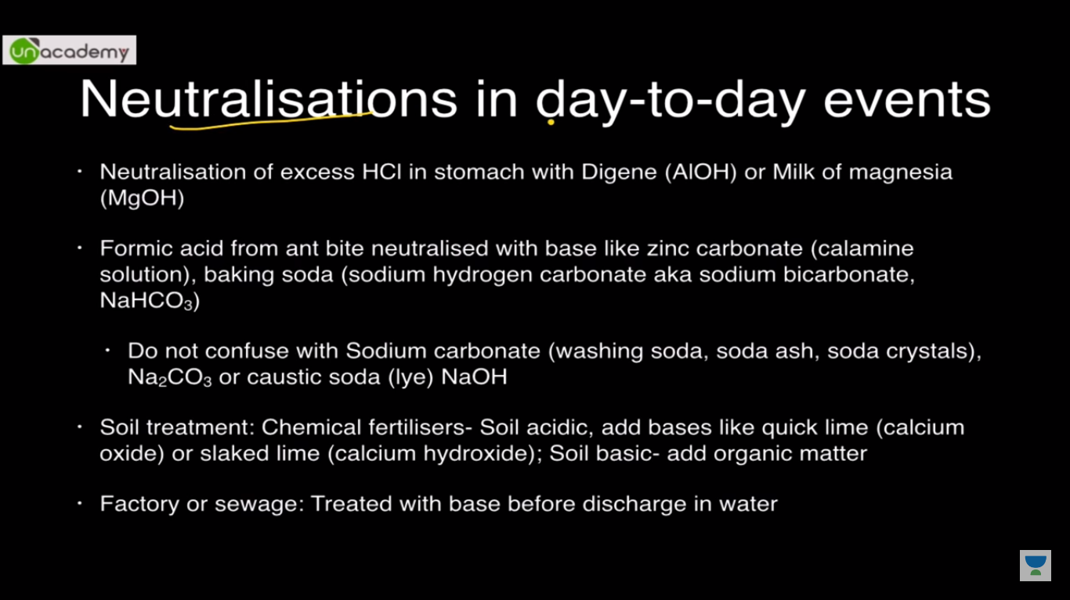

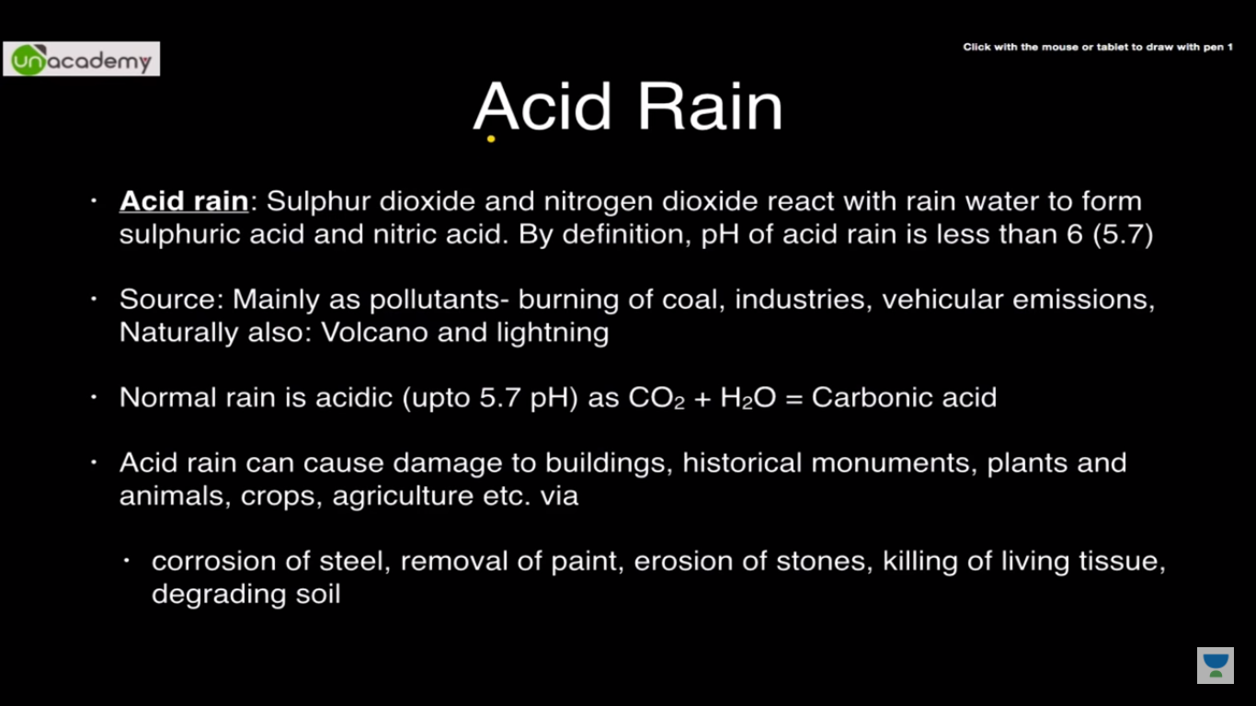

**Chapter 6**

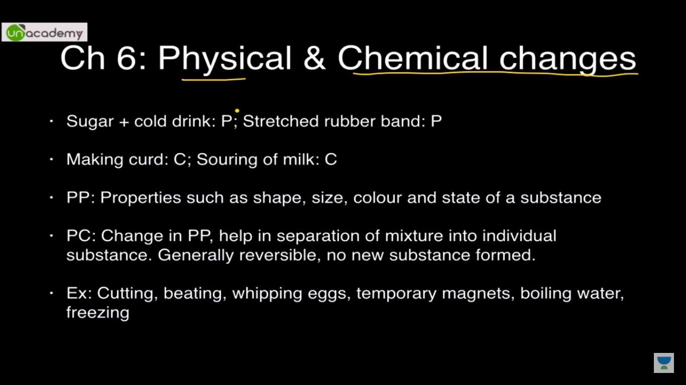

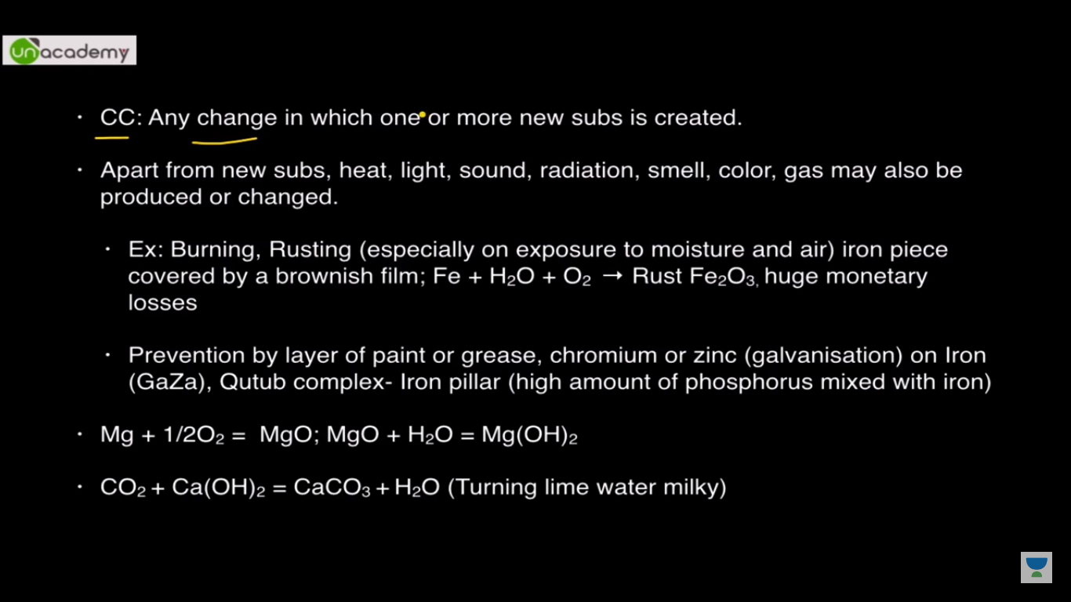

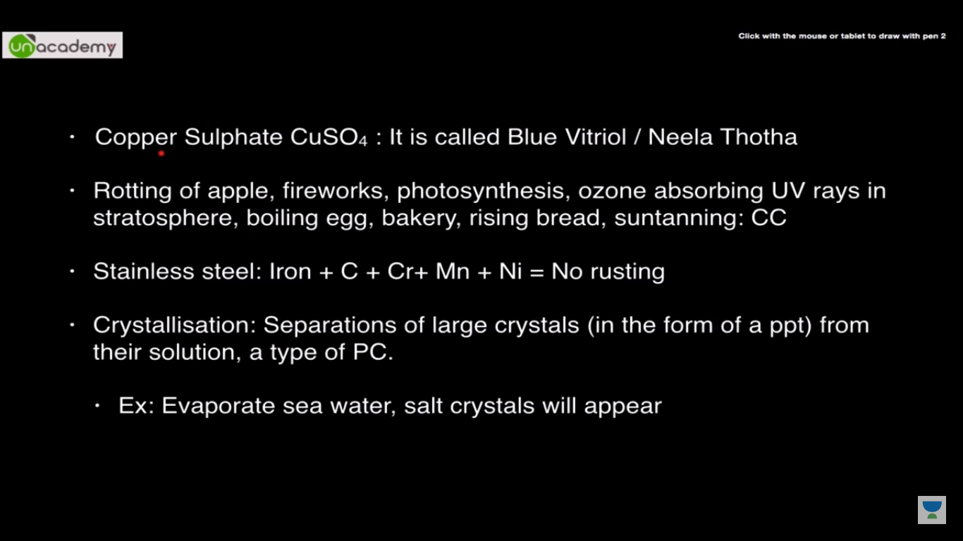

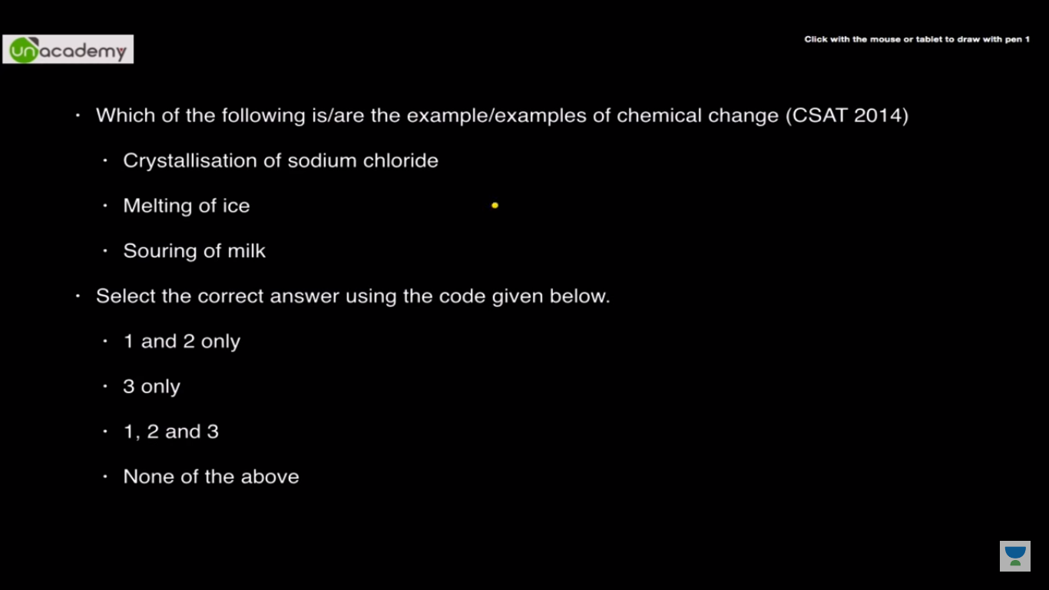

3 only

**Chapter 7:**

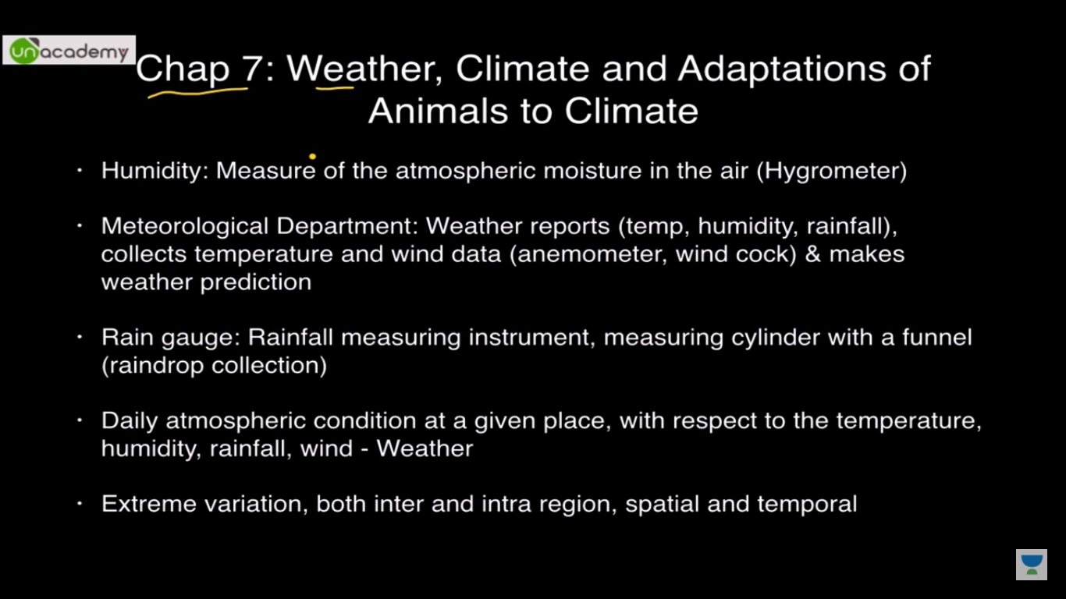

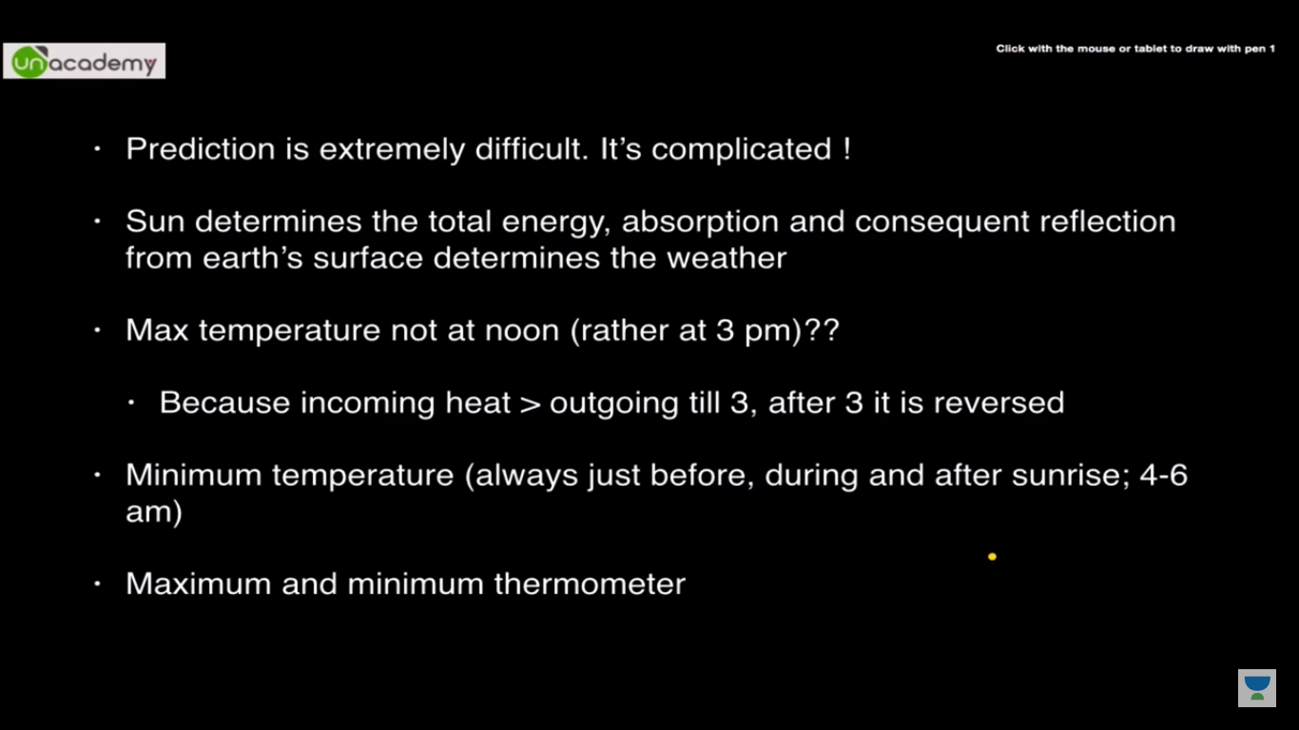

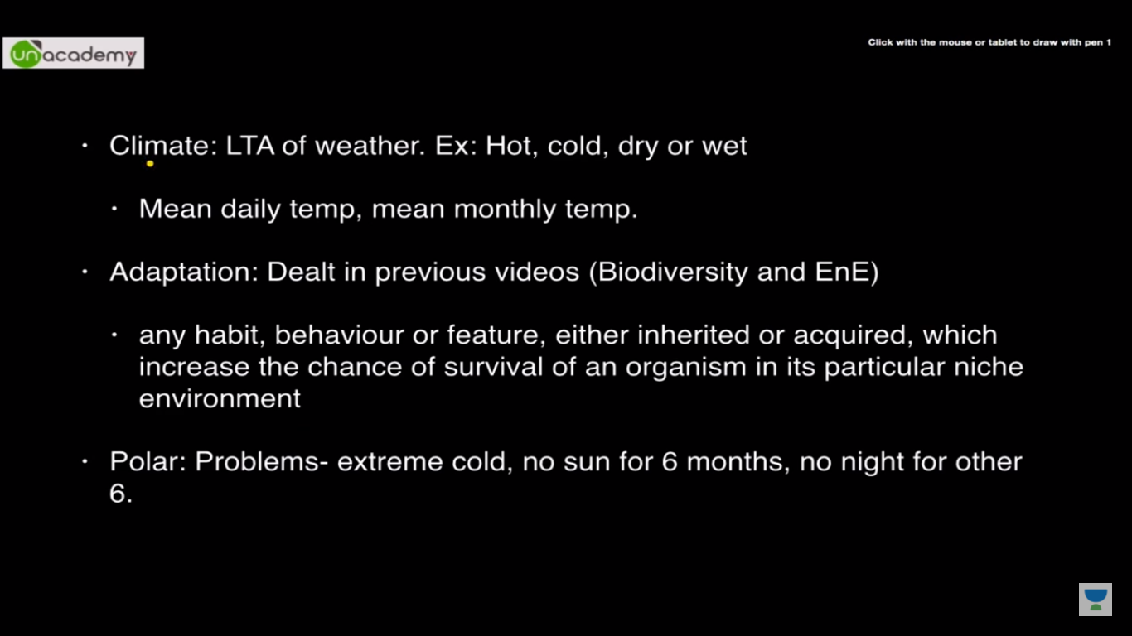

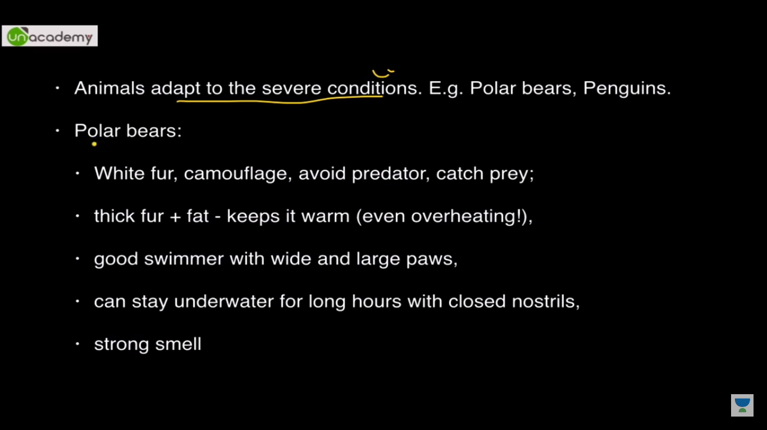

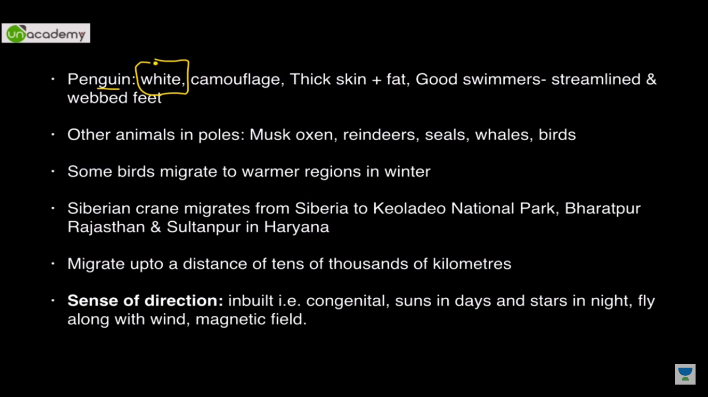

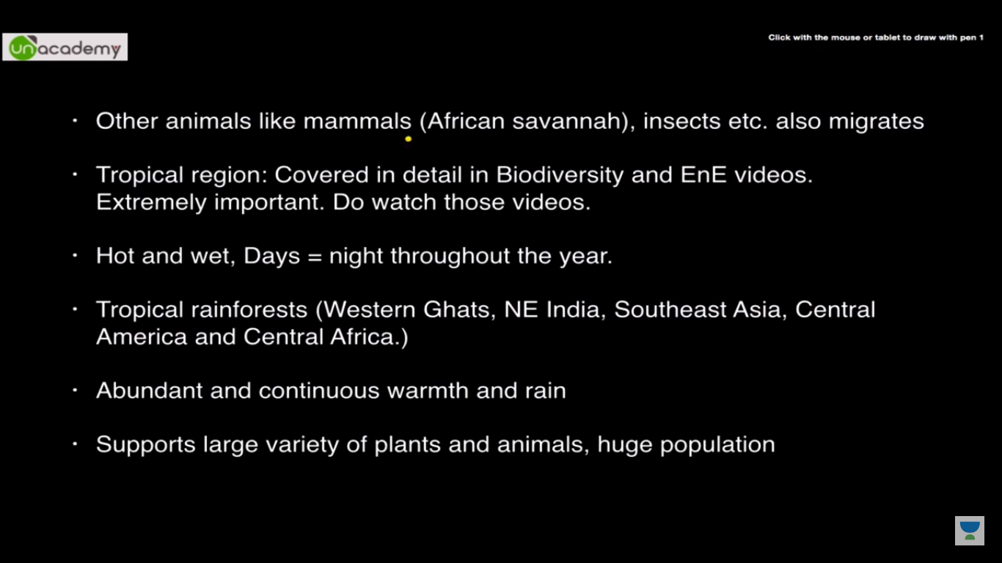

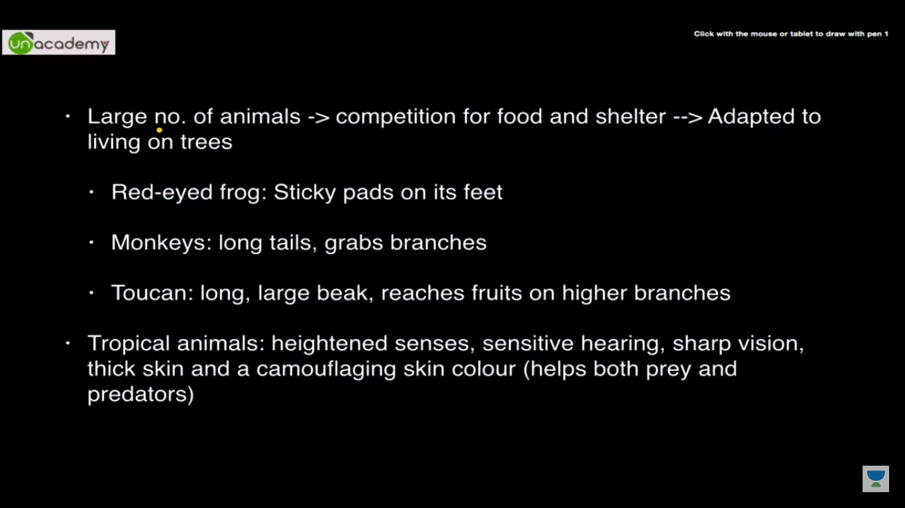

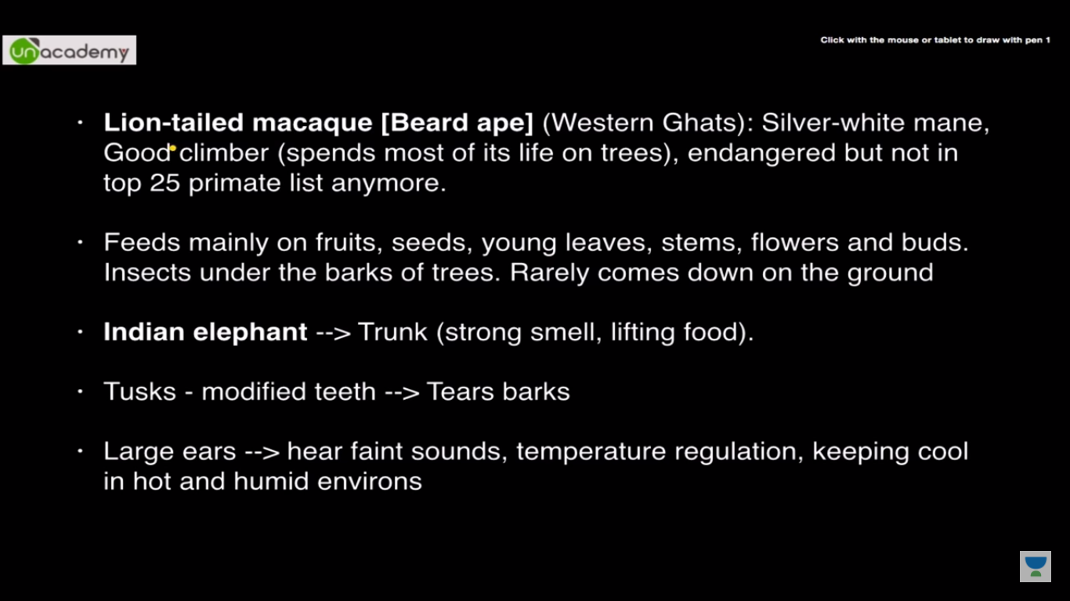

**Chapter 8**

* **Air exerts pressure**
* **High speed winds are accompanied by reduced air pressure**
* **Air moves from the region where the air pressure is high to the region where the pressure is low.**
* **Air expands on heating. The warm air is, therefore, lighter than the cold air.**
* **Wind currents are generated due to uneven heating on the earth.**

1. **Uneven heating between the equator and the poles**



1. **Uneven heating of land and water**

The monsoon winds carry water and it rains.

* **Thunderstorms and cyclones**

rising temperatures produce strong upward rising winds. These winds carry water droplets upwards, where they freeze, and fall down again. The swift movement of the falling water droplets along with the rising air create lightning and sound.

**Cyclone:**

Water takes up heat from the atmosphere to change into vapour. When water vapour changes back to liquid form as raindrops, this heat is released to the atmosphere. The heat released to the atmosphere warms the air around. The air tends to rise and causes a drop in pressure. More air rushes to the centre of the storm. This cycle is repeated. The chain of events ends with the formation of a very low-pressure system with very high-speed winds revolving around it. It is this weather condition that we call a **cyclone.**



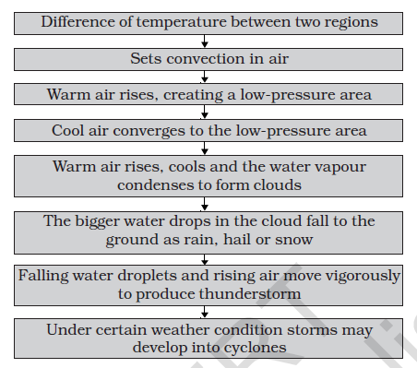

**Chapter 9**

**Soil**

* Polythene bags and plastics pollute the soil. They also kill the organisms living in the soil. That is why there is a demand to ban the polythene bags and plastics.
* The rotting dead matter in the soil is called **humus**.
* You probably know that the soil is formed by the breaking down of rocks by the action of wind, water and climate. This process is called **weathering**
* A vertical section through different layers of the soil is called the **soil profile**. Each layer differs in feel (texture), colour, depth and chemical composition. These layers are referred to as **horizons**



* soil fertile and provides nutrients to growing plants. This layer is generally soft, porous and can retain more water. It is called the **topsoil** or the **A-horizon**.
* The next layer has a lesser amount of humus but more of minerals. This

layer is generally harder and more compact and is called the **B-horizon** or the middle layer.

* The third layer is the **C-horizon**, which is made up of small lumps of rocks with cracks and crevices.
* Below this layer is the **bedrock**, which is hard and difficult to dig with a spade.

**SOIL TYPES:**

The mixture of rock particles and humus is called the soil.

If soil contains greater proportion of big particles it is called **sandy soil**.

If the proportion of fine particles is relatively higher, then it is called

**clayey soil**.

If the amount of large and fine particles is about the same, then the soil is called **loamy**.

Silt occurs as a deposit in river beds.

**PROPERTIES OF SOIL:**

Percolation rate of water in soil

percolation rate (mL/min) =amount of water (mL)/percolation time (min)

* On a hot summer day, the vapour coming out of the soil reflect the sunlight and the air above the soil seems to shimmer
* percentage of water absorbed=((U_V)/50)100
* Clayey and loamy soils are both suitable for growing cereals like wheat, and gram.
* For lentils *(masoor)* and other pulses, loamy soils, which drain water easily, are required.
* For cotton, sandy loam or loam, which drain water easily and can hold plenty of air, are more suitable.
* **Soil Erosion**-The removal of land surface by water, wind or ice is known as erosion. Plant roots firmly bind the soil. In the absence of plants, soil becomes loose. So it can be moved by wind and flowing water.

**Chapter 10**

**Respiration in organism**

* During breathing, we breathe in air. Air contains oxygen. We breathe out air which is rich in carbon dioxide.
* The air we breathe in is transported to all parts of the body and ultimately to each cell. In the cells, oxygen in the air helps in the breakdown of food. The process of breakdown of food in the cell with the release of energy is called **cellular respiration**. Cellular respiration takes place in the **cells of all organisms**.
* When breakdown of glucose occurs with the use of oxygen it is called **aerobic respiration**.
* Food can also be broken down, without using oxygen. This is called **anaerobic respiration**.
* yeast are anaerobes

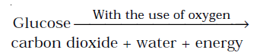

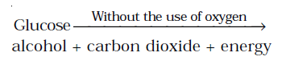

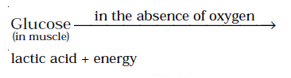

* Accumulation of lactic acid causes muscle cramps. The taking in of air rich in oxygen into the body is called **inhalation** and giving out of air rich in carbon dioxide is known as **exhalation**.
* On an average, an adult human being at rest breathes in and out 15ñ18 times in a minute.



Ribs

Lungs

Trachea

Pharynx

Diaphragam

Oral cavity

Nasal Passage

* When we inhale air, it passes through our nostrils into the **nasal cavity**. From the nasal cavity, the air reaches our **lungs** through the windpipe. Lungs are present in the **chest cavity** (Fig. 10.4). This cavity is surrounded by ribs on the sides. A large, muscular sheet called **diaphragm** forms the floor of the chest cavity. Breathing involves the movement of the diaphragm and the rib cage.

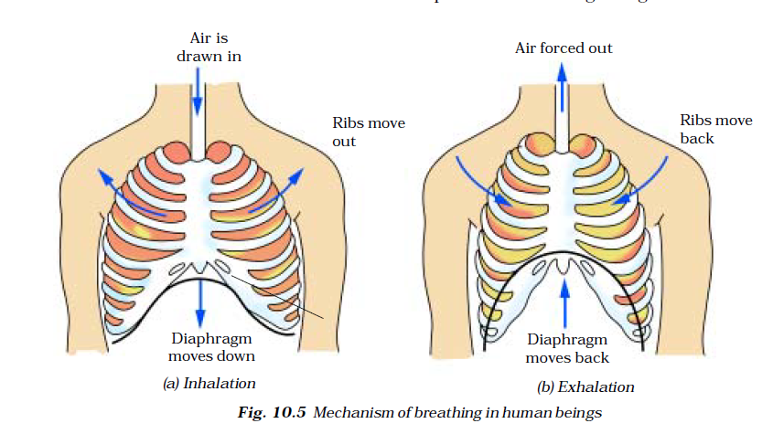

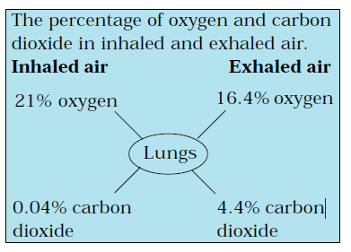

* ***Cockroach:*** A cockroach has small openings on the sides of its body. These openings are called **spiracles**
* Insects have a network of air tubes called **tracheae** for gas exchange
* Oxygen rich air rushes through spiracles into the tracheal tubes, diffuses into the body tissue, and reaches every cell of the body.
* ***Earthworm:*** skin of an earthworm feels moist and slimy on touching. Gases can easily pass through them.
* Though frogs have a pair of lungs like human beings, they can also breathe through their skin, which is moist and slippery.
* **Plants** take oxygen from the air and give out carbon dioxide
* In plants each part can independently take in oxygen from the air and give out carbon dioxide

**Chapter 11**

**Transportation in Animals And Plants**

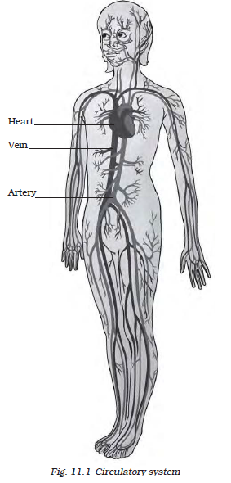

**CIRCULATORY SYSTEM**

**Blood:**

* Blood is the fluid which flows in blood vessels.
* It transports substances like digested food from the small intestine to the other parts of the body.
* It carries oxygen from the lungs to the cells of the body. It also transports waste for removal from the body.
* The fluid part of the blood is called plasma.
* **Red blood cells (RBC)** contain a red pigment called **haemoglobin**
* Haemoglobin bind with oxygen and transports it to all the parts of the body and ultimately to all the cells. Makes the blood appear red.
* **white blood cells (WBC)** which fight against germs that may enter our body.
* The clot is formed because of the presence of another type of cells in the blood, called **platelets.**

**Blood vessels**

* Two types of blood vessels are present in the arteries and veins of the body.
* **Arteries** carry oxygen-rich blood from the heart to all parts of the body. Arteries have thick elastic walls
* A resting person, usually has a pulse rate between 72 and 80 beats per minute.
* **Veins** are the vessels which carry carbon dioxide-rich blood from all parts of the body back to the heart. Thin wall
* There are valves present in veins which allow blood to flow only towards the heart.

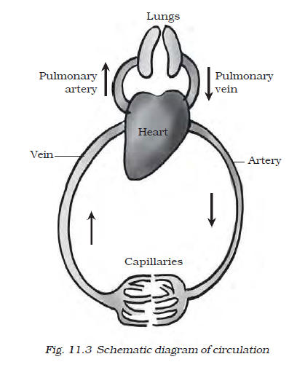

**Heart**

* The heart is an organ which beats continuously to act as a pump for the transport of blood, which carries other substances with it.
* Animals such as sponges and Hydra do not posses any circulatory system.
* The English physician, William Harvey (A.D.1578–1657), discovered the circulation of blood.

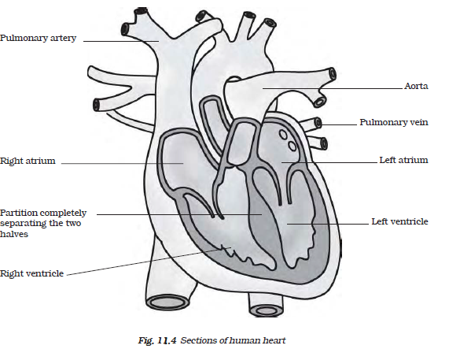

**Heartbeat**

* Rhythmic contraction followed by its relaxation constitute a heartbeat

**EXCRETION IN ANIMALS**

* The process of removal of wastes produced in the cells of the living organisms is called excretion. The parts involved in excretion forms the **excretory system**.

**Excretory system in humans:**

* When the blood reaches the two kidneys, it contains both useful and harmful substances. The useful substances are absorbed back into the blood. The wastes dissolved in water are removed as **urine**.

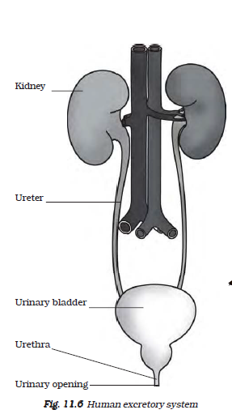

* The kindeys, ureters, bladder and urethra form the excretory system.
* An adult human being normally passes about 1–1.8 L of urine in 24 hours, and the urine consists of 95% water, 2.5 % urea and 2.5% other waste products.
* Aquatic animals like fishes, excrete cell waste in gaseous form (ammonia) which directly dissolves in water.

**TRANSPORT OF SUBSTANCES IN PLANTS:**

**Transport of water and minerals:**

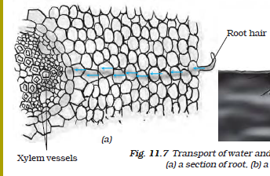

* The root hair increase the surface area of the root for the obsorption of water and mineral nutrients dissolved in water**.**
* Plants have pipe-like vessels to transport water and nutrients from the soil. The vessels are made of special cells, forming the **vascular tissue.**
* A tissue is a group ofcells that perform specialised function in an organism.
* The vascular tissue for the transport of water and nutrients in the plant is called the xylem
* The food has to be transported to all parts of the plant. This is done by the vascular tissue called the phloem.

**Transpiration:**

* The evaporation of water from leaves generates a suction pull (the samethat you produce when you suck water through a straw) which can pull water to great heights in the tall trees.
* Transpiration also cools the plant.

**Chapter13**

**Motion and Time**

**Speed**

speed is the total distance covered divided by the total time taken.

Distance covered = Speed Time

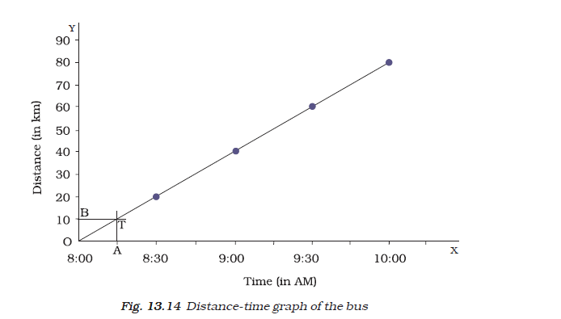

**Chapter 14**

**Electric Current and its Effect**

**SYMBOLS OF ELECTRIC COMPONENTS**

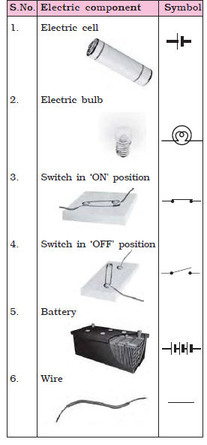

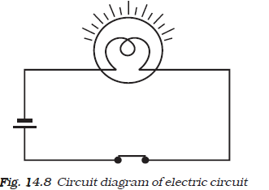

**HEATING EFFECT OF ELECTRIC current:**

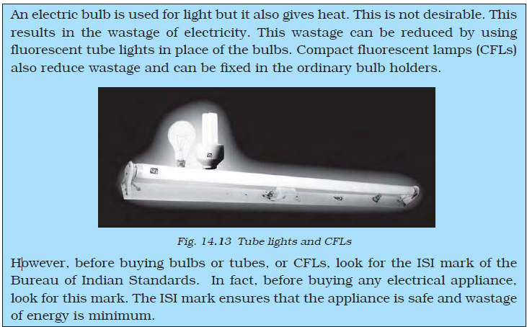

* Wires made from some special materials melt quickly and break when large electric currents are passed through them. These wires are used for making **electric fuses.**
* These days Miniature circuit breakers (MCBs) are increasingly being used in place of fuses. These are switches which automatically turn off when current in a circuit exceeds the safe limit.

**MAGNETIC EFFECT OF ELECTRIC CURRENT:**

* **Christian Oersted** was first person who noticed the deflection of compass needle every time the current was passed through the wire.

**ELECTROMAGNET**

* The electromagnets can be made very strong and can lift very heavy loads.
* The electromagnets are also used to separate magnetic material from the junk.
* Doctors use tiny electromagnets to take out small pieces of magnetic material that have accidentally fallen in the eye. Many toys also have electromagnets inside them.
* It consists of a coil of wire wound on an iron piece. The coil actsas an electromagnet. An iron strip with a hammer at one end is kept close to the electromagnet. There is a contact screw near the iron strip. When the iron strip is in contact with the screw, the current flows through the coil which becomes an electromagnet. It, then, pulls the iron strip. In the process, the hammer at the end of the strip strikes the gong of the bell to produce a sound. However, when the electromagnet pulls the iron strip, it also breaks the circuit. The current through the coil stops flowing.

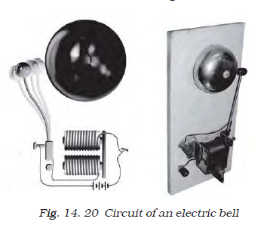

**Chapter 15**

**Light**

* Concave mirrors are used for many purposes. You might have seen doctors using concave mirrors for examining eyes, ears, nose and throat. Concave mirrors are also used by dentists to see an enlarged image of the teeth. The reflectors of torches, headlights of cars and scooters are concave in shape.
* Convex mirrors can form images of objects spread over a large area. So, these help the drivers to see the traffic behind them.

**IMAGES FORMED BY LENSES:**

* Those lenses which feel thicker in the middle than at the edges are convex lenses.
* which feel thinner in the middle than at the edges are concave lenses

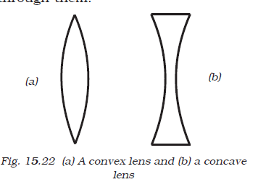

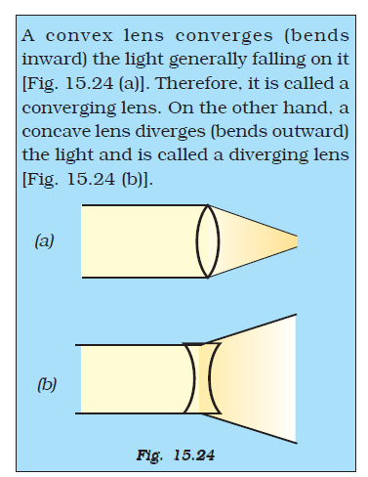

**Chapter 16**

**Water**

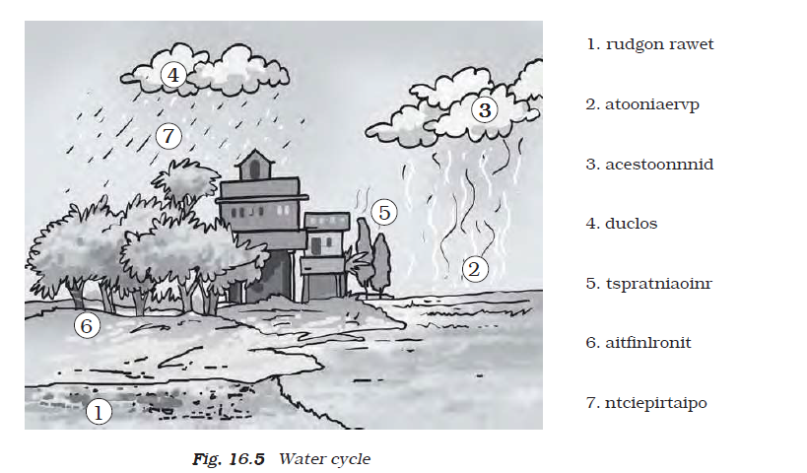

**GROUNDWATER AS AN IMPORTANT SOURCE OF WATER:**

* The upper limit of this layer is called the water table.
* The process of seeping of water into the ground is called infiltration.
* At places the groundwater is stored between layers of hard rock below the water table. This is known as an aquifer.

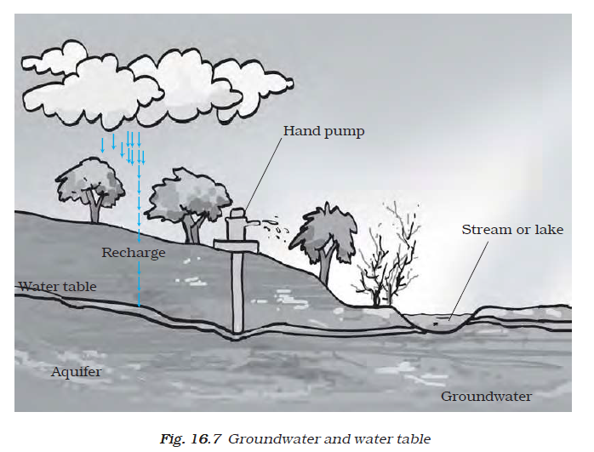

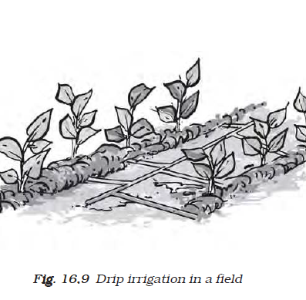

* Drip irrigation is a technique of watering plants by making use of narrow tubings which deliver water directly at the base of the plant.

**Chapter 17**

**Forests: Our Lifeline**

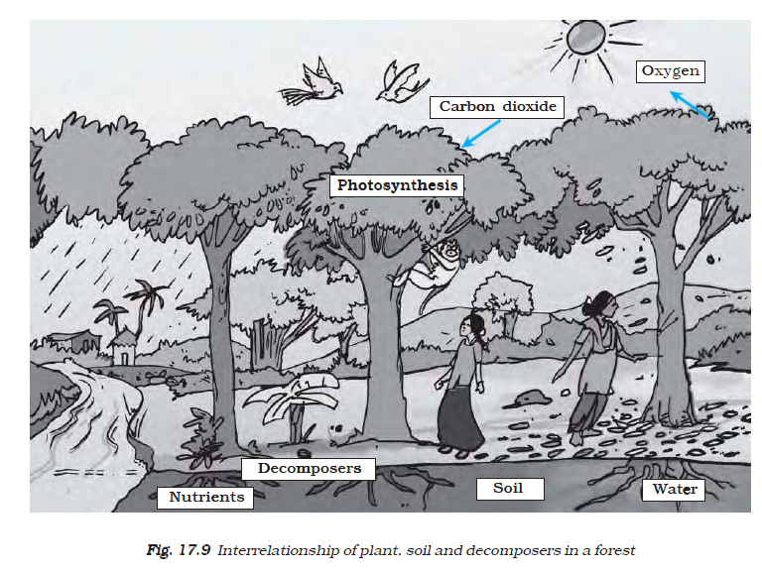

* Forests not only help in controlling floods but also help maintain the flow of water in the streams so that we get a steady supply of water.
* On the other hand, if trees are not present, rain hits the ground directly and may flood the area around it
* Heavy rain may also damages the soil. Roots of trees normally bind the soil together, but in their absence the soil is washed away or eroded.
* Noise pollution, too is less because the forest absorbs the noise of the nearby highway.

**What would happen if forests disappear**

* If forests disappear, the amount of carbon dioxide in air will increase, resulting in the increase of earth’s temperature.
* In the absence of trees and plants, the animals will not get food and shelter.
* In the absence of trees, the soil will not hold water, which will cause floods.
* Deforestation will endanger our life and environment.

**Chapter 18**

**Wastewater Story**

Cleaning of water is a process of removing pollutants before it enters a water body or is reused. This process of wastewater treatment is commonly known as “Sewage Treatment”. It takes place in several stages.

sewage is a complex mixture containing suspended solids, organic and inorganic impurities, nutrients, saprotrophic and disease causing bacteria and other microbes

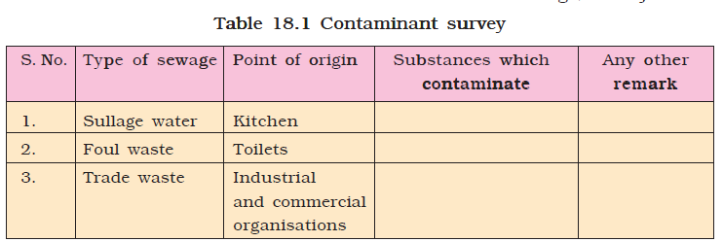

**WASTEWATER TREATMENT PLANT(WWTP):**

Treatment of wastewater involves physical, chemical, and biological processes, which remove physical, chemical and biological matter that contaminates the wastewater.

* Wastewater is passed through bar screens. Large objects like rags, sticks, cans, plastic packets, napkins are removed.
* Water then goes to a grit and sand removal tank. The speed of the incoming wastewater is decreased to allow sand, grit and pebbles to settle down.
* The water is then allowed to settle in a large tank which is sloped towards the middle. Solids like faeces settle at the bottom and are removed with a scraper. This is the sludge. A skimmer removes the floatable solids like oil and grease. Water so cleared is called clarified water.The sludge is transferred to a separate tank where it is decomposed by the anaerobic bacteria. The biogas produced in the process can be used as fuel or can be used to produce electricity.
* Air is pumped into the clarified water to help aerobic bacteria to grow. Bacteria consume human waste, food waste, soaps and other unwanted matter still remaining in clarified water.

**ALTERNATIVE ARRANGEMENT FOR SEWAGE DISPOSAL**

* septic tanks, chemical toilets, composting pits.
* Some organisations offer hygienic on-site human waste disposal technology. These toilets do not require scavenging. Excreta from the toilet seats flow through covered drains into a biogas plant